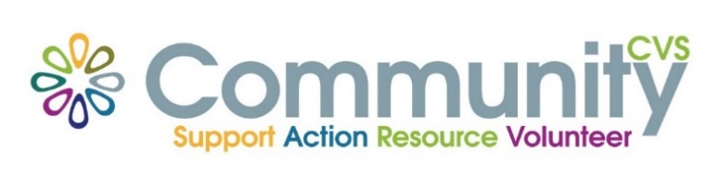

Community CVS
Network Meeting
Thursday 24th November 2022
9:30am – 11:30am
The Community Hub, 35 Railway Road, Blackburn
BB1 1EZ
Agenda
9.30am Introductions
09:45am Presentation from Paul Smithson from MS Society
10:00am Presentation from Victoria Braithwaite from Community Business Partners
10.15am Presentation from Alison Critchley from Sliding Doors
10.30am Updates
10.45am – Networking
Date of Next Meeting Thursday 26th January 2023
for more information please contact Donna Talbot 01254 583957
donna.talbot@CommunityCVS.org.uk

