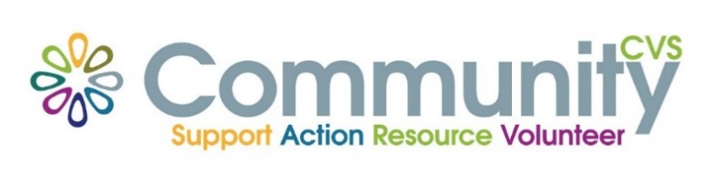

Community CVS
Network Meeting
Thursday 27th April 2023
9:30am – 11:30am
The Boulevard Centre, 45 Railway Road, Blackburn
BB1 1EZ
Agenda
9.45am Introductions
10.00am Chloe from BwD BC
10:15am Lisa from Green Patch
10.30am Tasha from Soberbee
10.45am Tamara from BYZ
11.00am – Victoria from BwD RE:FRESH
11.30am – Networking
Date of Next Meeting Thursday 25th May 2023
for more information please contact Donna Talbot 01254 583957
donna.talbot@CommunityCVS.org.uk

