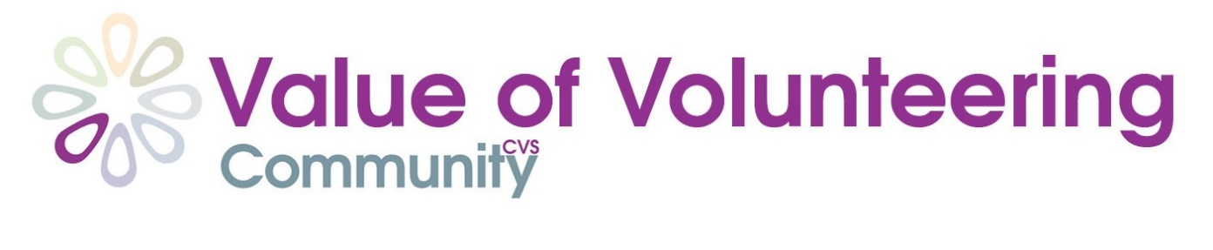
Volunteer Stories
We’d love to hear about what inspires you about volunteering – we think this is one of the best ways to convince people to get involved. You don’t have to answer all of the questions – just answer the ones relevant to your experience and please feel free to add any other thoughts or experiences that are important to you. If you’d prefer to do this as an interview rather than writing this down, please let us know and we would be happy to come out and speak to you.
Please submit your answers or preference for an interview to Kate.lee@communitycvs.org.uk
Thanks so much!

Full Name

Age

Email

Phone number

Name of group you volunteer with

What volunteer role do you do ?

What does it involve ?

What skills did you bring to the role

How long have you been volunteering for?

How did you first get involved/ find out about the role?

What was the first task you were given?

Why did you want to get involved as a volunteer?

What do you love about your role?

How have you benefited from volunteering?

Would you recommend volunteering to others?

Why?

Do you think others that you volunteer with have benefited in different way? If so how?

What’s your favourite volunteering memory?

What song best sums up your volunteering experience?

What would you say to someone who was unsure about whether to take part in volunteering?

Anything else you want to add!

Please include a photo (or video) of you volunteering !!

If you are filling this form on someone else’s behalf, please indicate that you have their permission to use their information in this way ☐
Please indicate by ticking the boxes that you/they are happy with the following:
o You/they agree that this information can be used on the Community CVS website and associated Community CVS social media to promote volunteering ☐
o You/they agree that these case studies can be distributed to local media and used on the NCVO website to promote volunteering ☐

