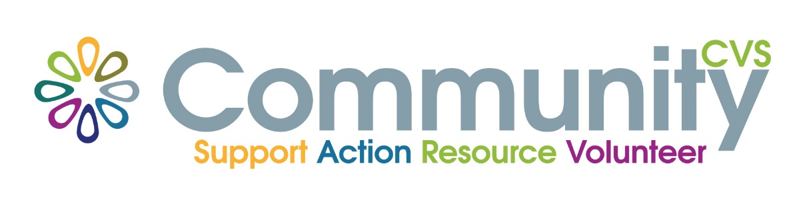

COMMUNITY CVS Annual General Meeting
Wednesday 10th May 2023
Held at
The Grand Venue, 2 Harrison Street, Blackburn. BB2 2JN
at
9.30am

Agenda

- Welcome and introductions

- Community CVS AGM
- Minutes of the last meeting 06/12/2021
- Trustees Annual Report
- Independent Audited Accounts 31 March 2022
- Appointment of Auditors
- Election of the Committee
Please refer to our website for supporting documents www.communitycvs.org.uk

- Summing up and Close

