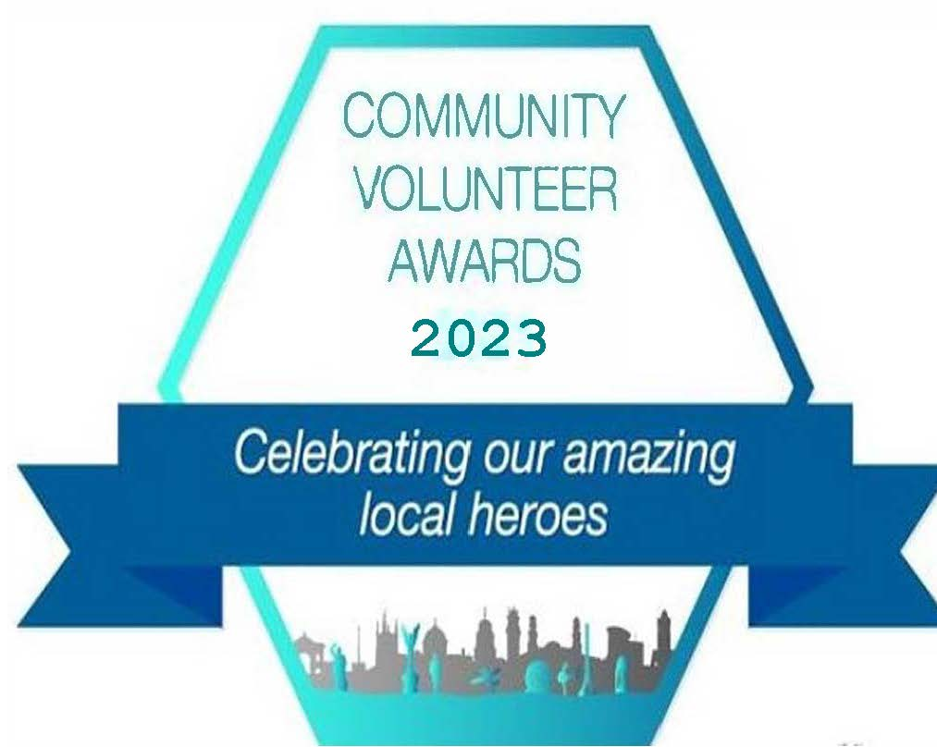

Sponsorship Packages

Community Volunteer Awards 2023

“What a wonderful night and very well organised. It was lovely to see and hear all the fantastic work our community volunteers deliver in our community.”

“It is nice to see volunteers and groups being recognised.”

“It was totally uplifting to be in the room with so many people who support others and make this town a better place.”

“The colourful decorations, the food , the music, all made such a dazzling impression after such a hard year.

My sense of optimism is completely restored this morning!”

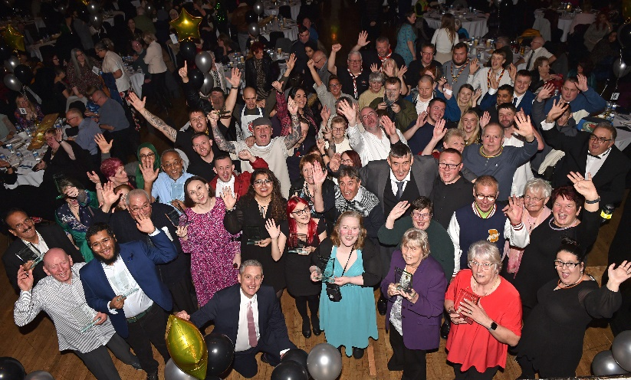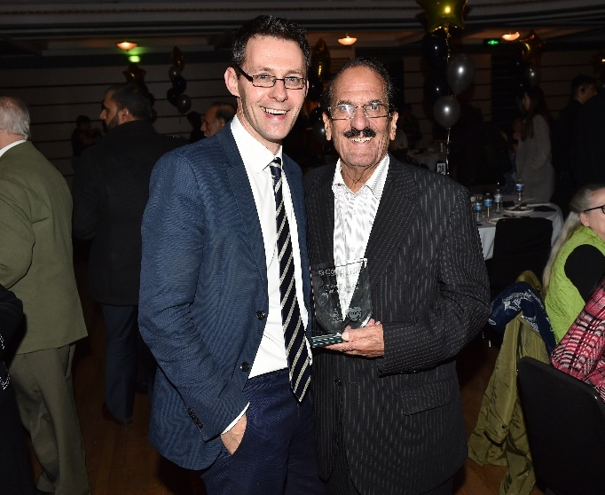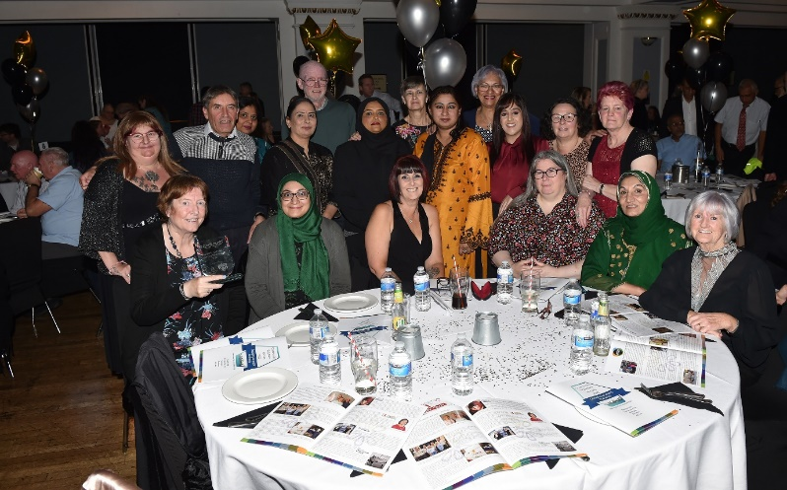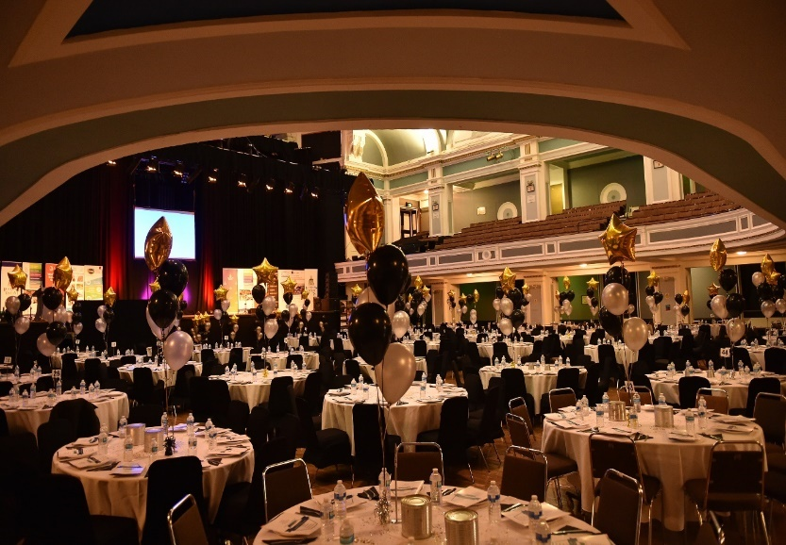

“We all felt honoured to have been selected as finalists and everyone felt special”

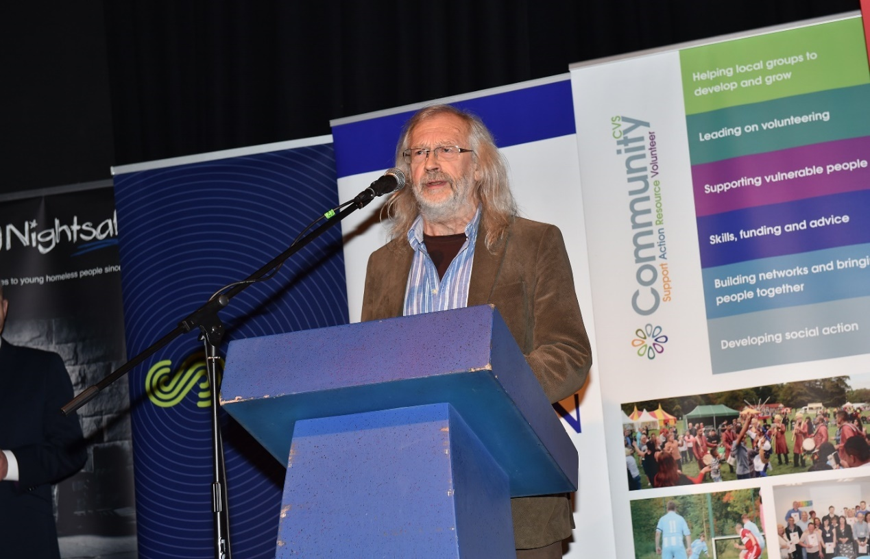

“Looking forward to the next one, everyone was really proud of their achievements, quite rightly……”

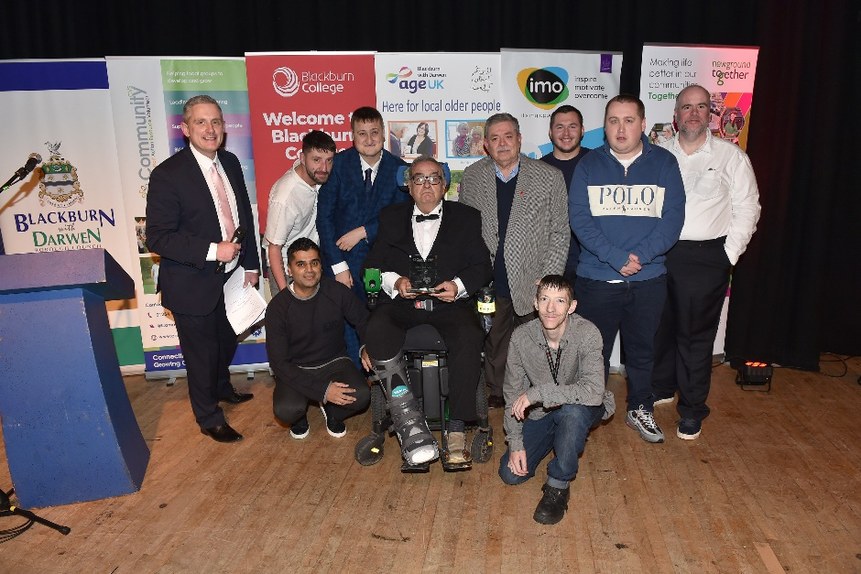

**“We had a fantastic night celebrating the successes of our local heroes and learning about their incredible personal achievements which have shaped our local community.”**

“The atmosphere was wonderful and the event was decorated beautifully…...The evening flowed well too, and before we knew it was over! “

“Thank you so much for an evening we will remember for a long time. My family and colleagues are very proud that I made it so far. It was lovely to be recognised.”

“It was quite overwhelming the number of Volunteers

 working so hard to support services, with no need or want of thanks – inspirational people”

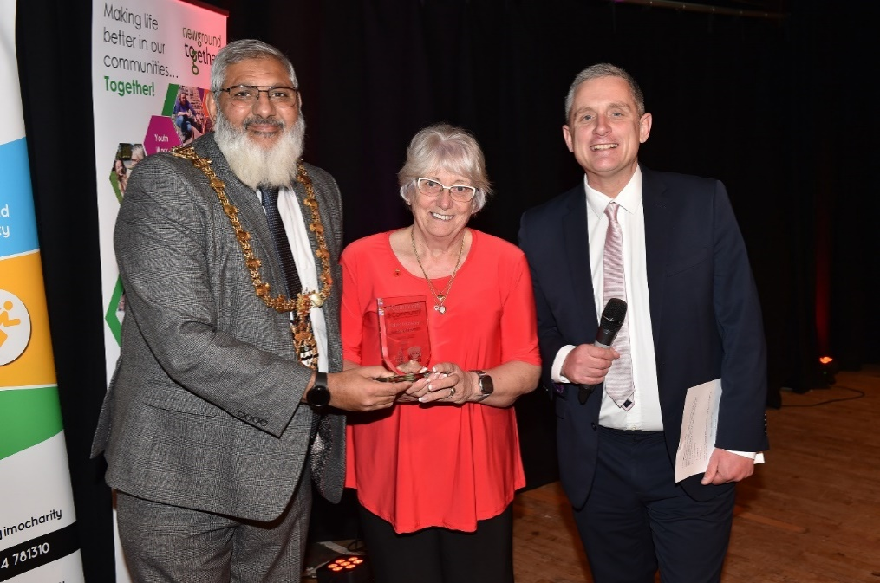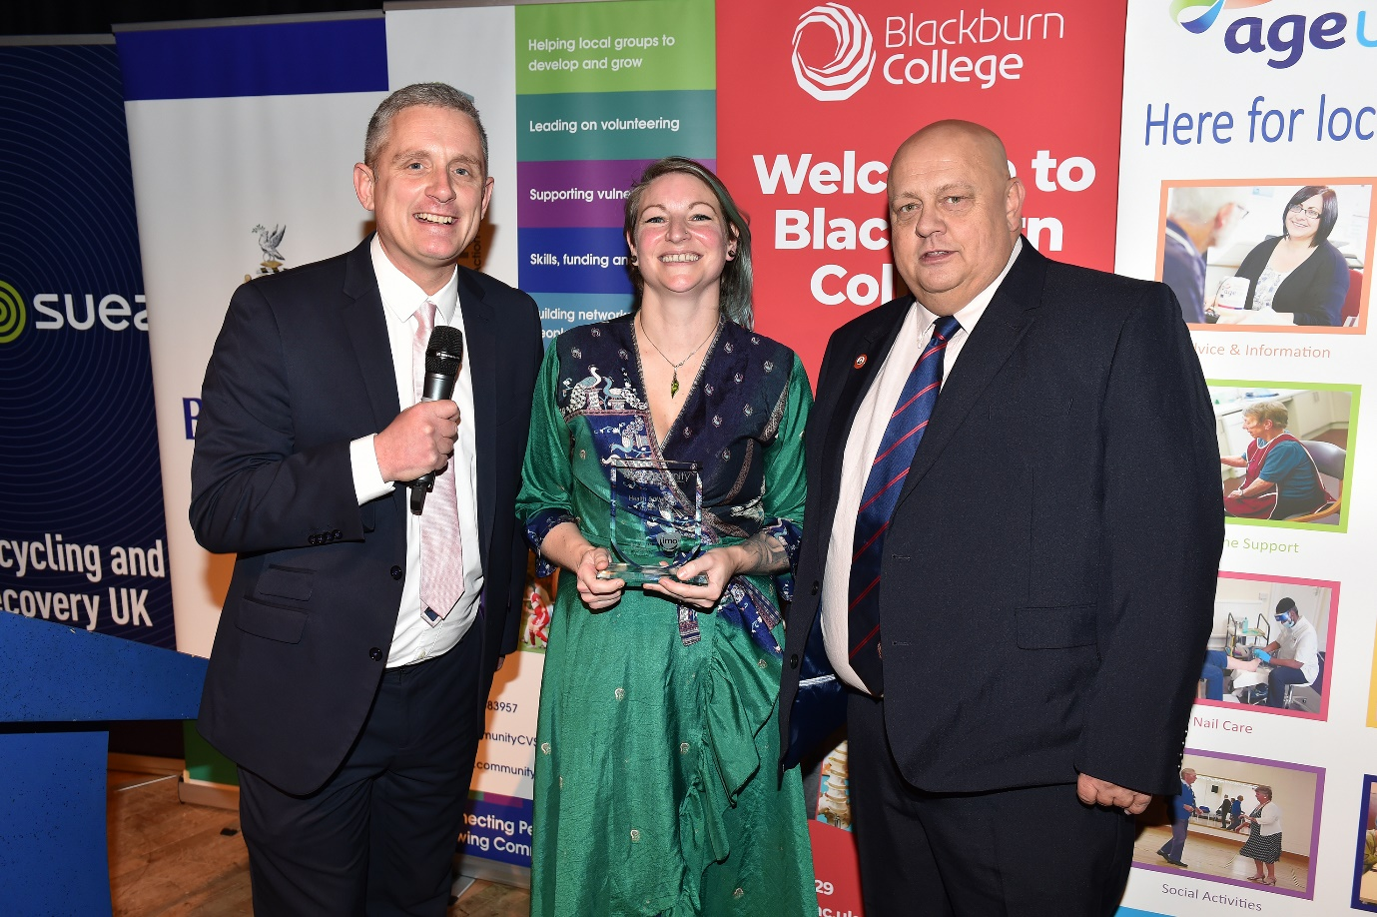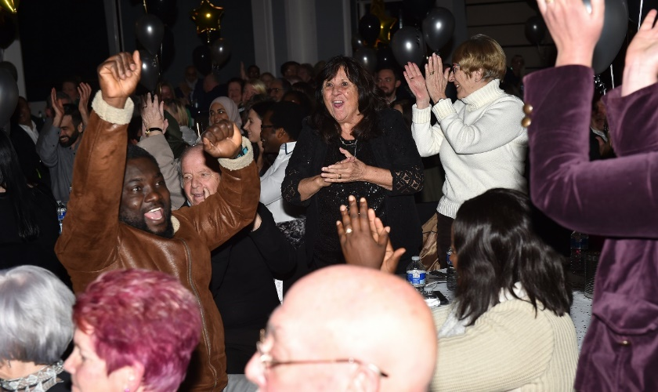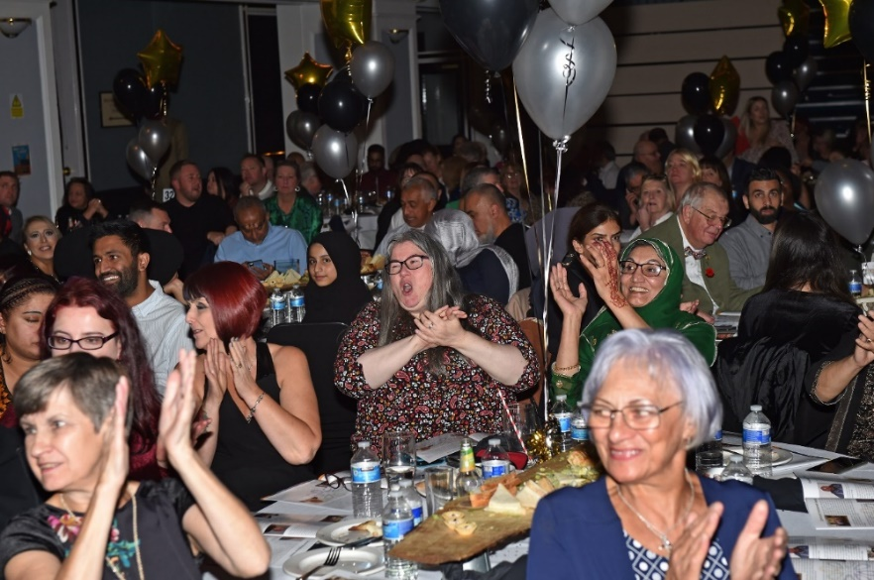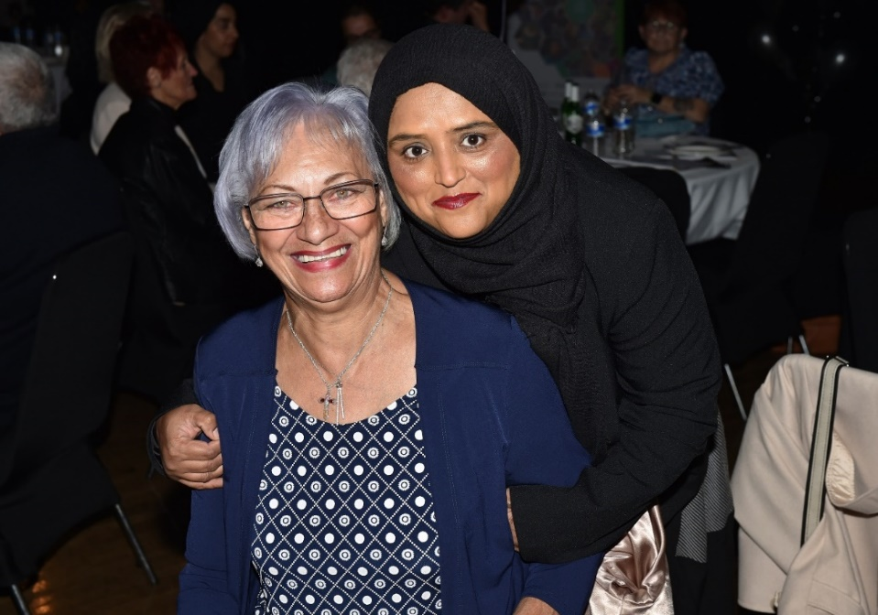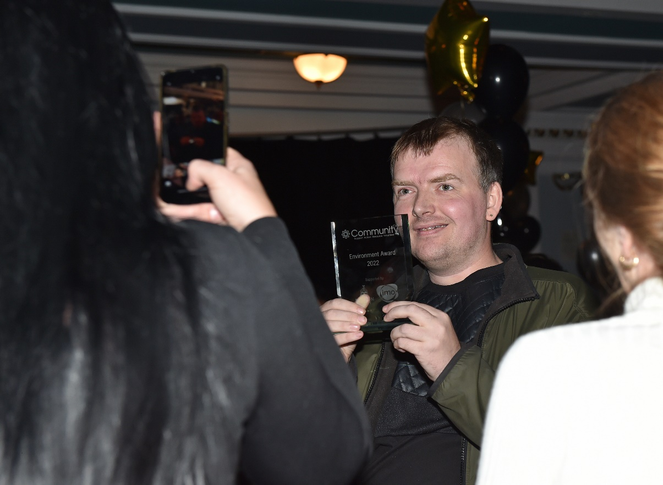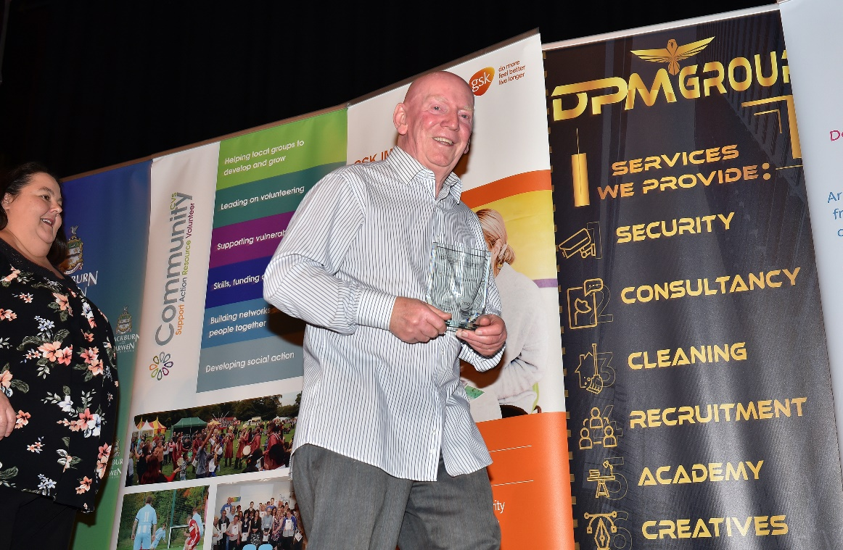

“All the Volunteers are stars….They give so much and deserve a great big thank you!! Thank you sponsors for making this evening so special”

Past Sponsors & Supporters

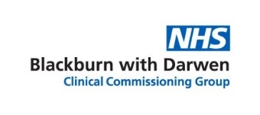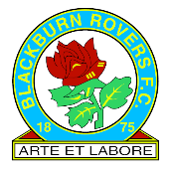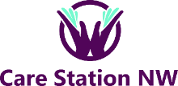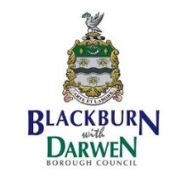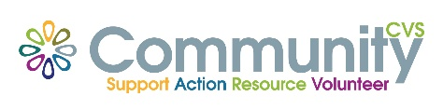

“Being a part of these projects has put us in touch with a network of incredible local volunteers who work tirelessly to make our community as vibrant and successful as it can possibly be – they really are the backbone of our community. Supporting the Community Volunteer Awards felt like a very natural thing for us to want to be a part.”

“This is our second year supporting the awards, we do this to ensure a platform is there for all services to nominate their amazing volunteers. To celebrate the wonderful work, they all do. All winners in our eyes”

“Recognising and celebrating volunteers is very important, it is important to recognise those who have taken their time and put their efforts into the community”

“We support these awards as we have seen first-hand the commendable work carried out across the Community and these groups/individuals deserve to be recognised. We will look to support them in any way we can.”

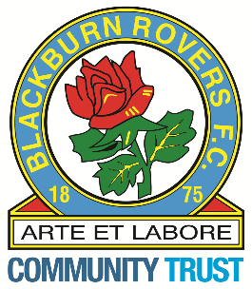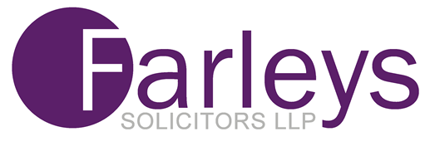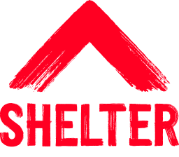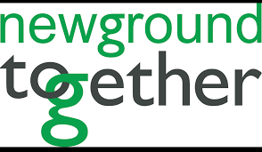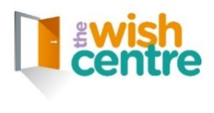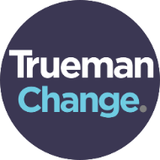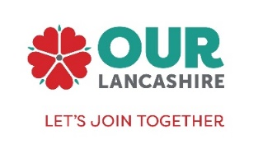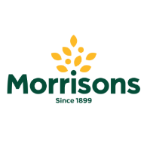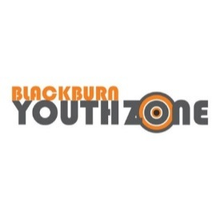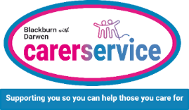

“We were thrilled to have the opportunity to support the awards. As a local, Blackburn based business, it’s great for us to hear about the excellent work going on locally, and we felt this year of all years we knew it was so important to celebrate volunteers, after seeing such a huge impact made during lock down “

“Community Volunteer Awards recognise the people often unseen in the background and we are proud that our organisation has been a supporter of these events for many years. We have continued to support financially, but it also, has also allowed the Company to connect with other sectors of the community, that we would normally, not have had access prior to our involvement with the CVS”

“The Community Volunteer Awards are a great way to support the community, thank our volunteers and all the other wonderful volunteers in Blackburn with Darwen for the amazing work they do.”

“The Community Volunteer Awards is a fantastic way of recognising the work of volunteers, it acknowledges the roles they have undertaken by celebrating them. The Awards offer the opportunity to get dressed up and feel pampered and looked after.

“The reason why we support the Community Volunteer Awards is because I understand the importance of the great work that these people do in the community, they deserve recognition and the Community Volunteer Awards is a good way to say - Thank you”

“The Community Volunteer Awards is a fantastic event so being a sponsor shows that the Wish Centre values and supports all the remarkable volunteers who attend, the event acknowledges the amazing contribution that they make and it also makes Blackburn with Darwen volunteers feel appreciated”

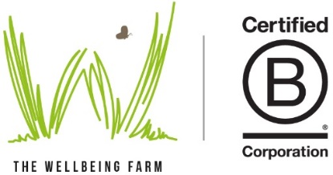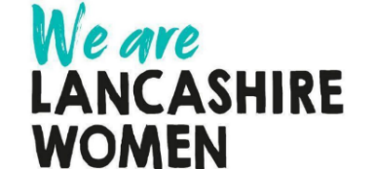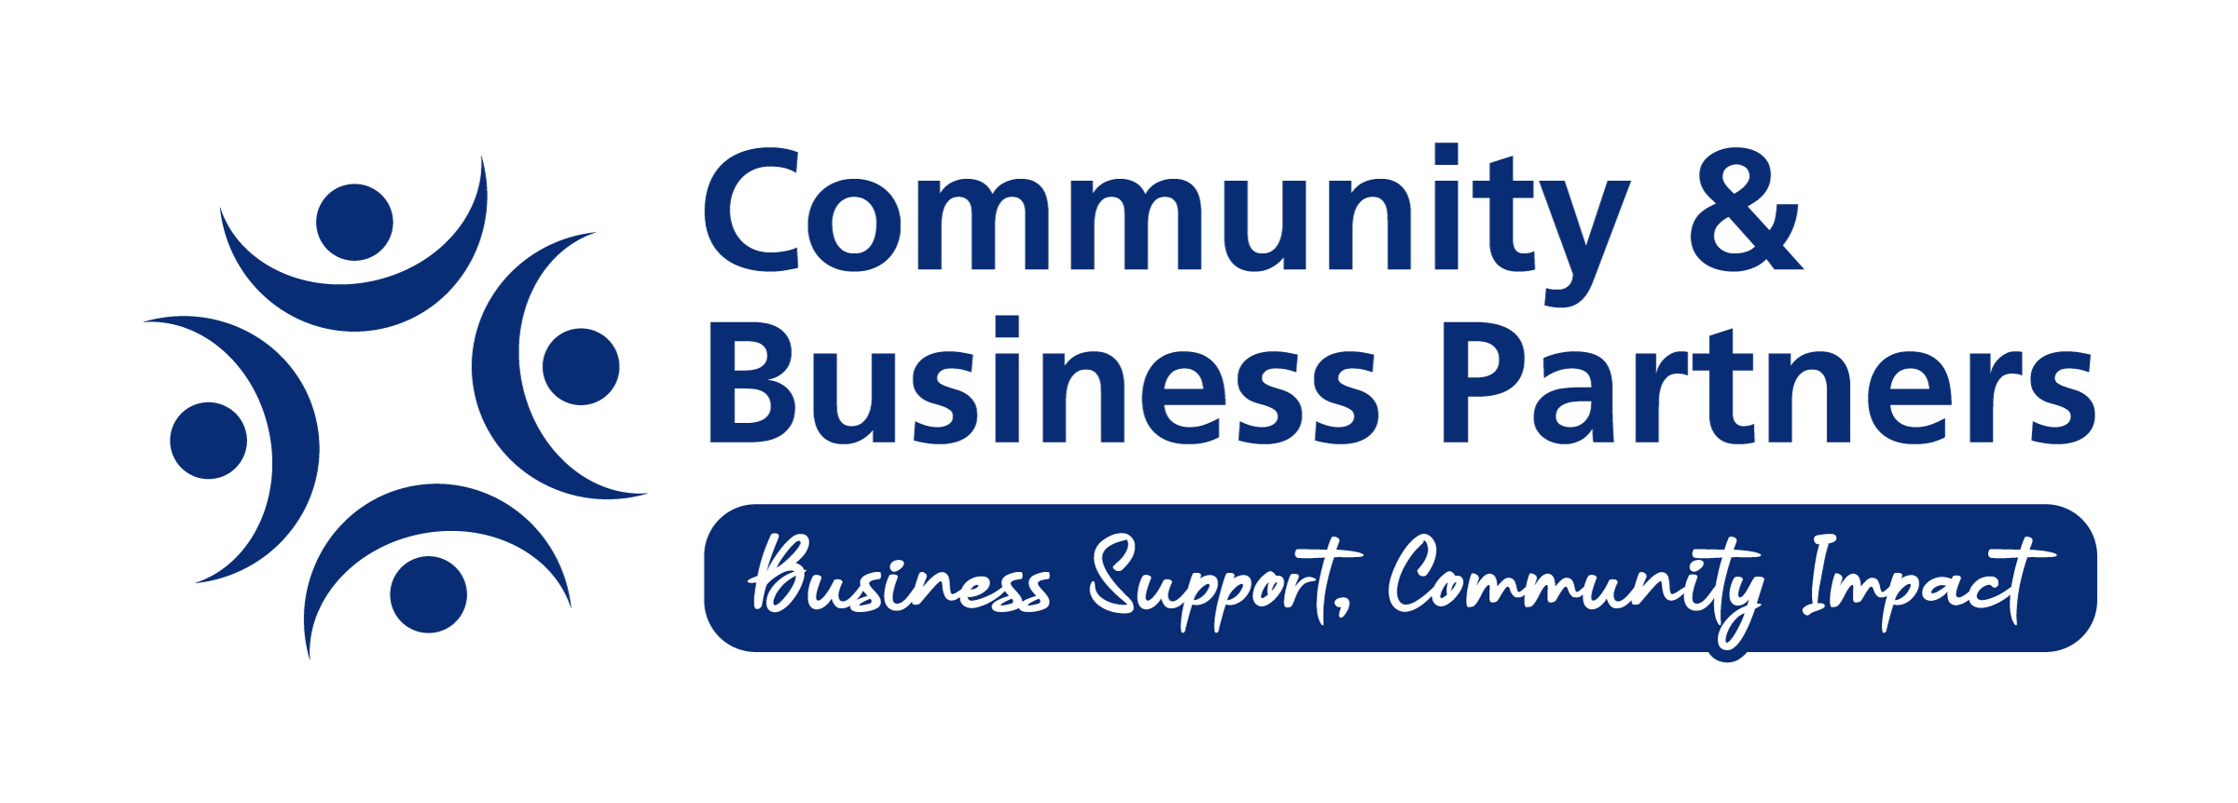

***Community Awards 2023 Sponsorship Packages***

**Gold package - £3,000**

* Main Sponsor of the Event
* Table at the event (10 guests max)
* Opportunity for a speech at the event
* Your logo on all marketing material main sponsor
* Mentioned in all publicity as main sponsor
* Advertising Space on the town Hall big screen (month)
* Advertising Space on the Larkhill Screen (two weeks)
* Advertising space on BwD BC digital totems (month)
* One full page advert with design costs in The Shuttle
* Part of the main judging panel
* Full page spread - Event Programme (A4)
* Opportunity to hand out an award

**Silver package - £1,000**

* Guests at the event (5 max)
* Opportunity to hand out award
* Your logo on all marketing material as a sponsor
* Mentioned in all publicity as a sponsor
* Part of the main Judging panel
* Advertising Space on the big screen (equivalent of one week)
* Advertising Space on BwD BC digital totems (Two Weeks)
* One half page advert in The Shuttle
* 1/2 page – Event programme (A4)

**Community Package - £500**

* Guests at the event (2 max)
* Opportunity to hand out an award
* Your logo on all marketing material
* Mentioned in all publicity as a sponsor
* Part of the judging panel
* 1/4 page – Event programme (A4)