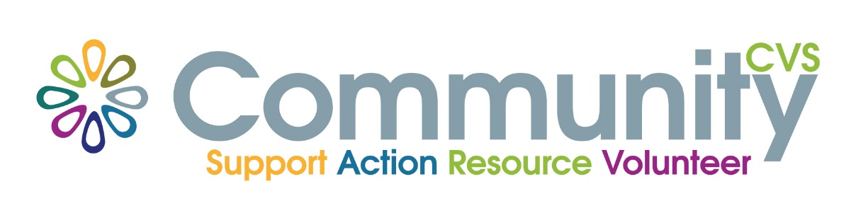

COMMUNITY CVS Annual General Meeting
Tuesday 4th June 2024
Held at
The Hornby Lecture Theatre, Blackburn Central Library,
Town Hall Street, Blackburn
at
2.15pm

Agenda

- Welcome and introductions

- Community CVS AGM
- Minutes of the last meeting 10th May 2023
- Trustees Annual Report
- Independent Audited Accounts 31 March 2023
- Appointment of Auditors
- Election of the Committee
Please refer to our website for supporting documents www.communitycvs.org.uk

- Summing up and Close

