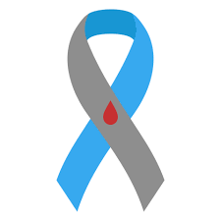

BwD Diabetes Peer Support Group
Diabetes Awareness Event
Wednesday 12th Jun 2024
12:00pm – 4:00pm
The Community Wellbeing Hub
Darwen End, Ewood Park, Blackburn
For all people interested in diabetes
Mini Health Checks by Wellbeing Service

for more information, please contact Paul: bwddiabetesgroup@outlook.com

