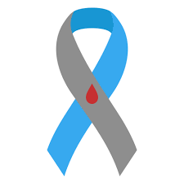

BwD Diabetes Peer Support Group
For Adults (18 yrs. plus) affected by Diabetes
Come along have a Brew & Chat, Meet other adults with diabetes
Starting May 2024
Blackburn Central Library
Town Hall Street, Blackburn, BB2 1AG
Monthly drop-in first Tuesday of the month 1:00pm - 3:00pm
Monthly evening group third Tuesday of the month
7:00pm - 9:00pm
The Community Wellbeing Hub
Darwen End, Ewood Park, Blackburn
Monthly drop-in second Wednesday of the month
3:00pm - 7:00pm
for more information, please contact Paul: bwddiabetesgroup@outlook.com

