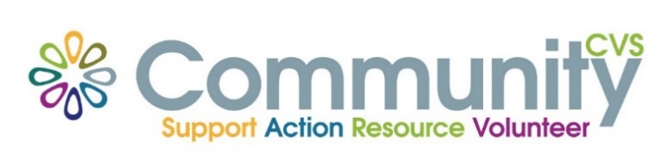

Community CVS Network Meeting
Thursday May 23rd 2024
9:30am – 11:30am
The Boulevard Centre, 45 Railway Road, Blackburn
BB1 1EZ
Agenda
9.45am Introductions
10.00am Christina from BwD Parents in Partnership
10:10am Leroy from Positive Action in the Community
10.20am Parisa from Just Run for Today
10.30am Kelly from Champions
10.40am Bushra from Lancashire Women
10:50am Lauren from PAC-UK
11.05am - Updates
11.15am – Networking
Date of Next Meeting Thursday 27th June 2024
for more information please contact Donna Talbot 01254 583957
donna.talbot@CommunityCVS.org.uk

