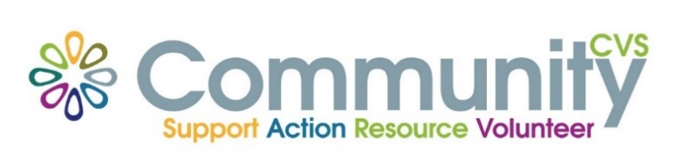

Community CVS Network Meeting
Thursday June 27th 2024
9:30am – 11:30am
The Boulevard Centre, 45 Railway Road, Blackburn
BB1 1EZ
Agenda
9:30am Introductions
9:45am Angel from IPS
9:50am Janine from Blackburn College
10:00am Verity from Lagans Foundation
10:10am Luckman from The Phoenix Way
10:20am Uzma from Four Seasons Outdoors
10:30am Linda from BwD BC -Healthy Weight Network
10:40am – Updates AOB
11:00am – Networking
Date of Next Meeting Thursday 25th July 2024
for more information please contact Donna Talbot 01254 583957
donna.talbot@CommunityCVS.org.uk

