**Meeting Minutes – Flying Start Business Network**  
**Date:** 05/12/2024

**Speaker 1**: Dee Gough, The Pacific Institute

**Speaker 2**: Michael Spencer, Style Mentoring UK

**Speaker 3**: Eden Maskill-Watts, Eden MW Design Studio

**Speaker 4**: Mohammad Rizwan, Aspire Accounting & Tax Aid

|  |  |  |
| --- | --- | --- |
| Name | Organisation | Email |
| Leah Harrison | Community CVS | [Leah.harrison@communitycvs.org.uk](mailto:Leah.harrison@communitycvs.org.uk) |
| Dee Gough | The Pacific Institute | dee.gough@pacificinstitute.co.uk |
| Michael Spencer | Style Mentoring UK | michael@stylementoring.co.uk |
| Emma Bolton | Bolton HR | emma@boltonhr.co.uk |
| Sarah Fletcher |  | sarah@sarahfletchercoaching.com |
| Yvette Holden | Selnet | Yvette@selnet-uk.com |
| Mike Walker | Stop press | mike@stoppress.co |
| Salim Chaudhry |  | salim_c_uk@yahoo.co.uk |
| Mohammad Rizwan | Aspire Accounting & Tax Aid | rizzyalpha@gmail.com |
| Eden Maskill-Watts | Eden MW Design Studio | hello@edenmw.com |
| Nina Cowell | Selnet | nina@selnet-uk.com |
| Abiola Laiyenfe | Hermitage Healthcare Limited | info@hermitagehealthcare.co.uk |
| Philip Quinn |  | phil_quinn@hotmail.com |
| Alex Gould | Alex's Organisational Services | alex@alex-gould.co.uk |
| Eamonn Gottlieb |  | eamgottlieb@gmail.com |
| Daniel Cavallo | Despair 2 Hope | daniel@despair2hope.org |
| Allan Harle | Harle Tech 3D Printing | allan@harle.tech |
|  |  |  |
|  |  |  |

1. **Speaker**: Dee Gough, The Pacific Institute

**Overview:**  
Dee Gough is a mindset and transformational change consultant who works with individuals and organisations to help them achieve their goals and unlock potential by focusing on mindset. Her work emphasises how beliefs and attitudes shape actions, acting as either barriers or catalysts to success.

**Personal Journey**:  
Dee's interest in mindset began during a 30-year career in corporate finance with NatWest and the Royal Bank of Scotland. Around 12 years ago, a director introduced the Pacific Institute’s mindset programme to senior staff, sparking Dee's passion for the subject. After engaging with the programme, she became a facilitator, delivering training to help others understand how mindset affects behaviours and outcomes.

**Key Insights on Mindset**:

* **Understanding Mindset**: Our beliefs are learned and can be unlearned. Mindset dictates whether we see challenges as opportunities or barriers.
* **Leadership Transformation**: Dee shared a story of a toxic leader who initially resisted mindset changes but eventually adopted a more collaborative approach, transforming the work culture for their team.
* **Mindset Diagnostic Tool**: The "Blueprint," a modern diagnostic tool developed by Michael O’Brien and Amy Young, measures mindset and provides actionable insights for personal and organisational growth. Unlike older tools, it focuses on developing a growth mindset and improving workplace dynamics.

**Community Focus**:  
Dee expressed a desire to bring mindset coaching to Lancashire businesses and leaders, emphasising its life-changing potential and business benefits.

**Engagement with Clients**:  
Services are tailored to client needs, offering both in-person and remote sessions. Programmes are designed for teams and individuals, often involving initial training followed by cost-effective staff-led rollouts.

**Key Takeaway**:  
Mindset awareness leads to improved leadership, collaboration, and personal growth, with far-reaching positive impacts on individuals, teams, and communities.

1. **Speaker**: Michael Spencer, Style Mentoring UK

**Overview**:  
Michael, the founder of Style Mentoring, shared his journey of establishing his business in 2023, aiming to empower and support young people. Drawing on his extensive experience in child protection, social work, and coaching, Michael transitioned from a traditional employment role to running his own mentoring service. His passion lies in connecting with young people, building their self-belief, and addressing behavioural and emotional challenges, often using activities such as football, music, and golf.

**Personal Journey**:  
Michael described his professional background, which began as a football coach and evolved into roles in children’s services, including working with families and children in care. This experience inspired him to create a business model that provides tailored support, particularly for those struggling with education, family challenges, or mental health.

**Key Insights**:  
Michael acknowledged the challenges of setting up Style Mentoring, including the steep learning curve, the administrative hurdles of working with schools, and moments of doubt. However, his determination, supported by his son’s encouragement and practical advice, helped him persevere. He recently secured contracts with schools in Oldham and Blackburn with Darwen and is exploring opportunities to expand.

**Key Takeaways**:

* **Core Values**: Passion, self-belief, and adaptability.
* **Business Focus**: Tailored mentoring for young people, leveraging recreational and educational activities.
* **Challenges**: Balancing growth, navigating business complexities, and identifying potential collaborators or staff.
* **Advice**: Pursue your vision with passion, take advice from experienced peers, and remain patient with the growth process.

**Next Steps**:  
Michael plans to continue expanding his network and impact across Lancashire while refining his business model.

1. **Speaker**: Eden Maskill-Watts, Eden MW Design Studio

**Overview**:  
Eden Maskill-Watts, founder of Eden M-W Design Studio, shared insights into branding and graphic design, focusing on how businesses can effectively develop and maintain their brand identity. Eden’s background in video editing, teaching, and graphic design has enabled them to create a business that supports businesses with logos, branding, and design work. They also introduced a new service where they act as a temporary in-house designer for businesses needing regular design support.

**Key Insights**:

* **Branding Essentials**:
  1. **A Clear, Unique Brand Name**: Ensure your name is consistent across platforms and easy to remember.
  2. **Colour Scheme**: Choose primary, secondary, and accent colours (e.g., Coca-Cola’s red, silver, and black). Apply the “70-20-10” rule to balance these colours in designs.
  3. **Fonts**: Use two complementary fonts—one for headlines and another for readability.
  4. **Branding Strategy**: Consistently present your brand across all mediums, from social media to physical ads.
* **Additional Tips**:
  1. Create reusable **templates** for social media and other designs.
  2. Develop a **style guide** to ensure consistency in typography, colours, and other design elements.
  3. Ensure legal considerations for trademarks, especially when choosing a brand name.

**Trademarks and Legal Advice**:

* Verify that your brand name is unique and doesn’t conflict with existing companies in your field. Tools like **Companies House** and trademark registries through Intellectual Property on Gov.uk can help with this.
* **Global trademarking** isn’t necessary unless you're trading internationally or generating substantial revenue.

**Services Offered**:  
Eden provides branding, logo design, website design, social media graphics, style guides, and works alongside SEO and UX professionals for a comprehensive service. They also offer a new service where businesses can hire them as a temporary in-house designer for £500 per month, providing 10 hours of design support for tasks such as social media graphics, menus, flyers, and posters.

**Next Steps**:  
Eden plans to continue offering design services to businesses of all sizes while expanding their portfolio. Eden encourages anyone needing branding or design support to get in touch.

1. **Speaker**: Mohammad Rizwan, Aspire Accounting & Tax Aid

**Overview**:  
Mohammad Rizwan, an AAT-licensed accountant and graduate of Lancaster University in Accounting and Finance, shared valuable insights on business compliance, structures, and financial planning. Mohammad founded Aspire Accounting & Tax Aid Limited to provide tailored accounting and tax solutions for UK businesses, with the goal of supporting growth and profitability.

**Key Points Discussed**:

1. **Compliance**:
   * HMRC’s increasing compliance burdens, such as Making Tax Digital, require businesses to stay proactive.
   * Mohammad shared a case where he resolved a £2,000 tax fine for a client and secured a £700 tax rebate, highlighting the importance of keeping personal and business finances in order to avoid costly penalties.
2. **Business Structures**:
   * **Sole Traders**: Simpler to set up but with limited flexibility, best for those needing immediate access to profits.
   * **Limited Companies**: Offer tax efficiency, flexibility, and benefits such as lower dividend tax rates and capital allowance claims.
   * **Limited Liability Partnerships (LLPs)**: Gaining popularity for merging businesses and sharing profits.
   * **Group Structures**: Useful for companies reinvesting profits into subsidiaries, allowing for tax deferral and strategic growth.
3. **The Accountant’s Role**:
   * Mohammad emphasised the need for accountants to go beyond transactional relationships, focusing on strategic planning and offering financial clarity to business owners.
   * Example: For a frozen food wholesaler, he provided comprehensive support, including VAT registration, cash flow management, and deferred duty schemes.
4. **Value-Based Pricing**:
   * Aspire focuses on results-driven, value-based pricing rather than hourly billing, aiming to provide time-saving solutions and help clients achieve financial freedom.
5. **Bookkeeping**:
   * Mohammad stressed the foundational importance of bookkeeping for accurate financial management.
   * Aspire offers bookkeeping services and educates clients to develop their own systems, ensuring financial literacy and cost management.

**Business Operations and Vision**:

* Mohammad currently manages all technical accounting himself, with family support for marketing.
* He plans to scale Aspire by hiring employees and expanding services while maintaining quality.

**Challenges and Opportunities**:

* While Mohammad occasionally handles disorganised client records, he uses streamlined systems for efficiency.
* He avoids crypto-related accounting due to regulatory uncertainties but remains open to exploring new areas within established frameworks.

**Closing Thoughts**:  
Mohammad concluded by reiterating his commitment to empowering businesses with practical financial solutions, sharing his belief that businesses thrive with the right strategy, support, and planning. He welcomed questions and feedback, emphasising the importance of continuous learning and growth.

**About the Boost and Flying Start Programme**

**Overview**

The Flying Start service is for early-stage businesses that have traded for less than three years, and aspiring individuals with a great business idea. It is aimed at leaders who have a bright and growing vision for their new business. This service will focus on building business and financial acumen and the core skills to establish a new business and drive sustainable growth.

The advisers on the Flying Start programme have a wealth of experience helping early businesses and entrepreneurs and can provide helpful advice across a wide range of areas including business structure, financial management and bookkeeping, sales and marketing and business planning.  
  
This service is available to businesses within the following partner local authority areas: Blackburn with Darwen Borough Council, Burnley Council, Chorley Council, Fylde Council, Hyndburn Borough Council, Pendle Borough Council, Preston City Council, South Ribble Borough Council, West Lancashire Borough Council and Wyre Council.

**Next Steps**:

* Interested individuals can contact Boost / Selnet for a consultation and guidance on starting or scaling their business.  
  -Link: [Welcome to Boost Flying Start](https://selnet-uk.com/welcome-to-boost-flying-start/)
* Flying Start Business Surgery sessions for those who wish to attend:  
  -The Business Advice Surgery, is a free drop in service available to anyone.  
  -The next session will be held on the 12/12/2024, 9.45am-11.45am at the Community CVS Boulevard centre in Blackburn.   
  -Where attendees will be seen on a first come first serviced basis, for a maximum of half an hour with one of our Business Advisors.  
  - Link: [Boost Flying Start - Business Advice Surgery | Boost Events](https://boostevents.evolutive.co.uk/event/details/1586087/Boost-Flying-Start---Business-Advice-Surgery)

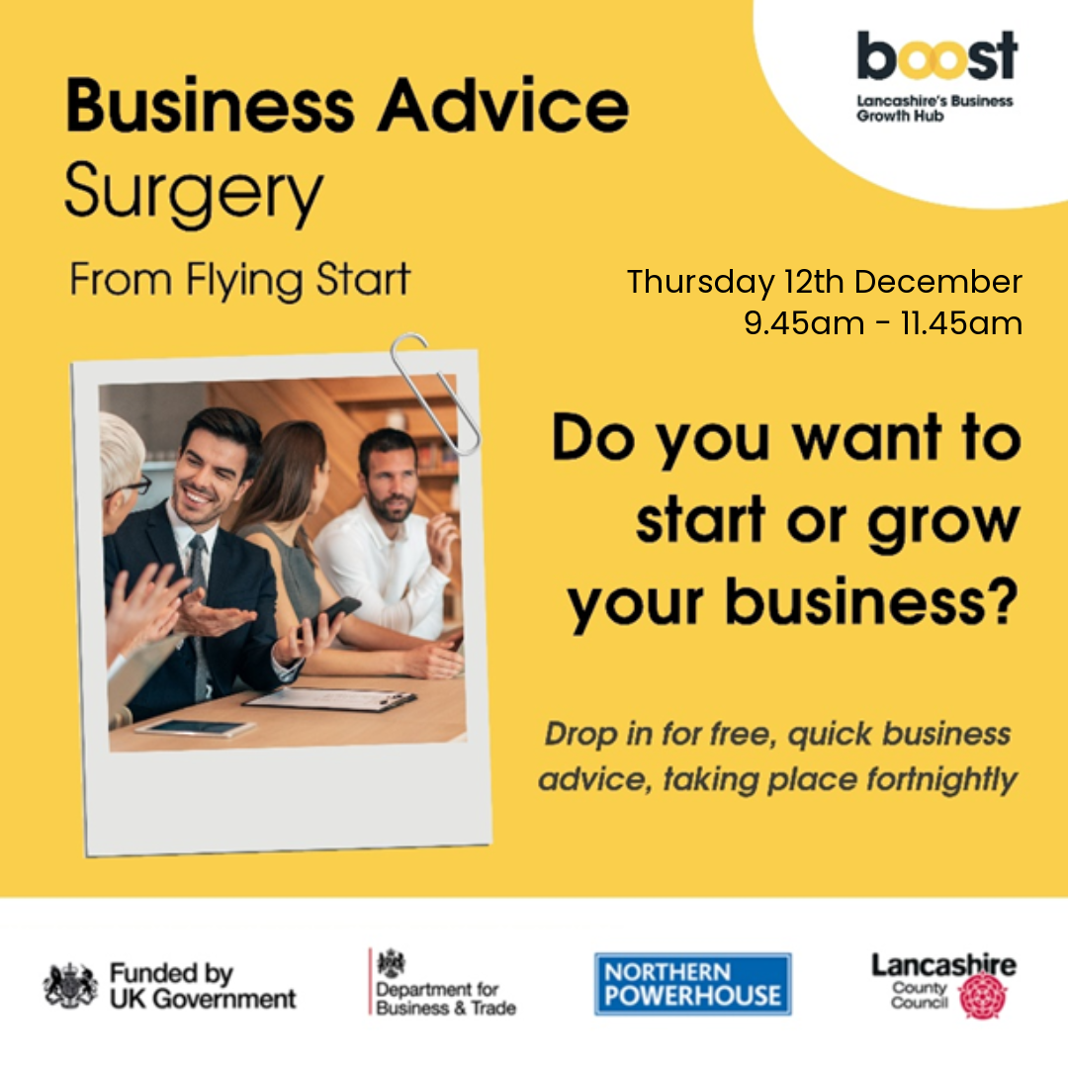

**Additional Information**

**Business Card Raffle Winner:** Mohammad Rizwan **Don’t forget your Business Cards for the Next One!**

**Photos:**

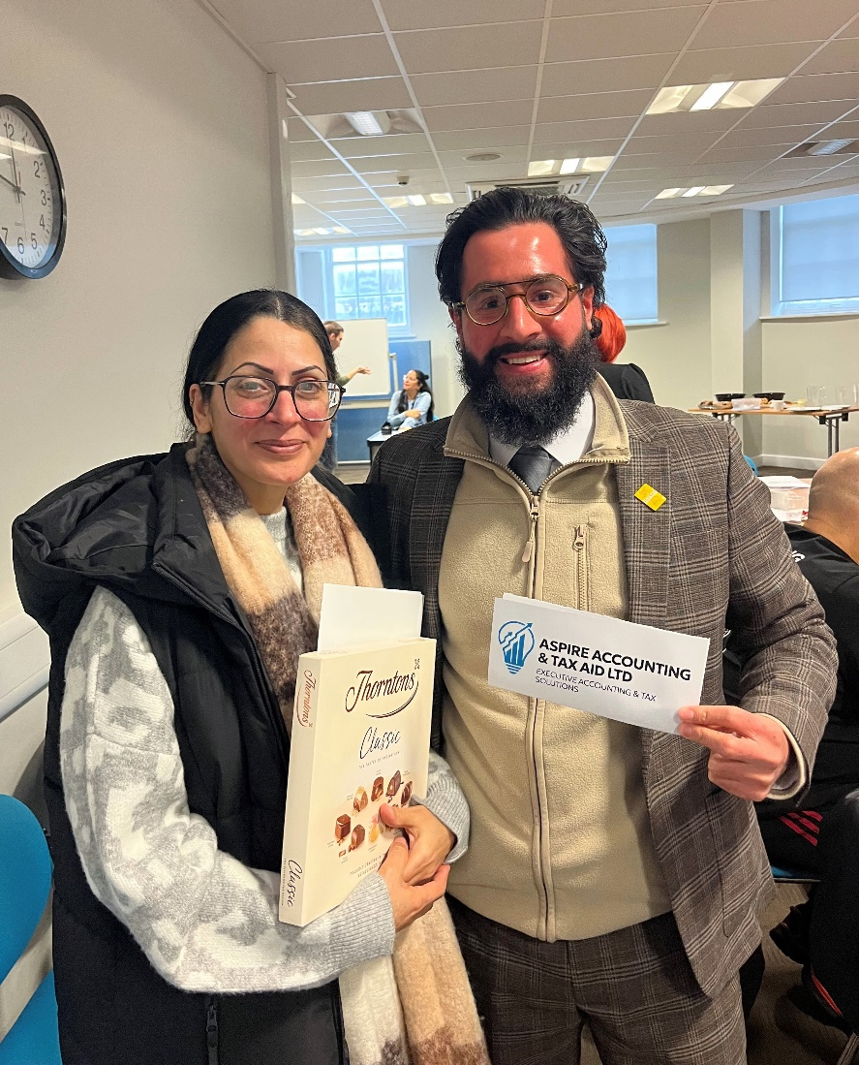

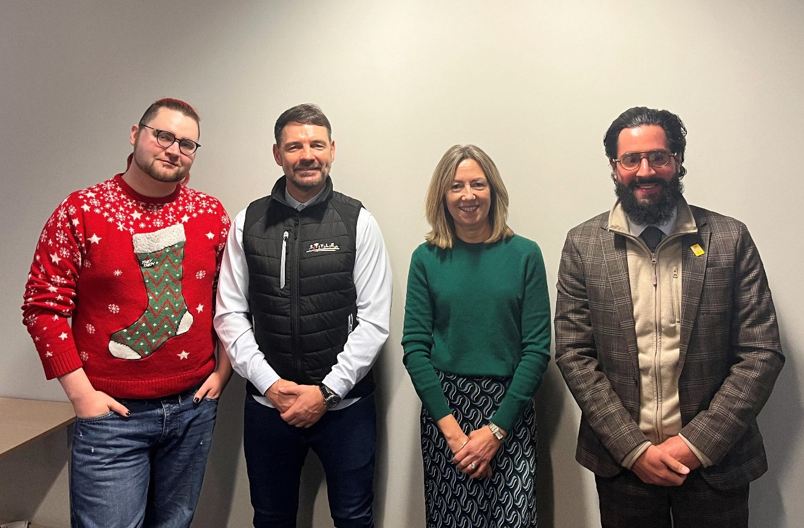

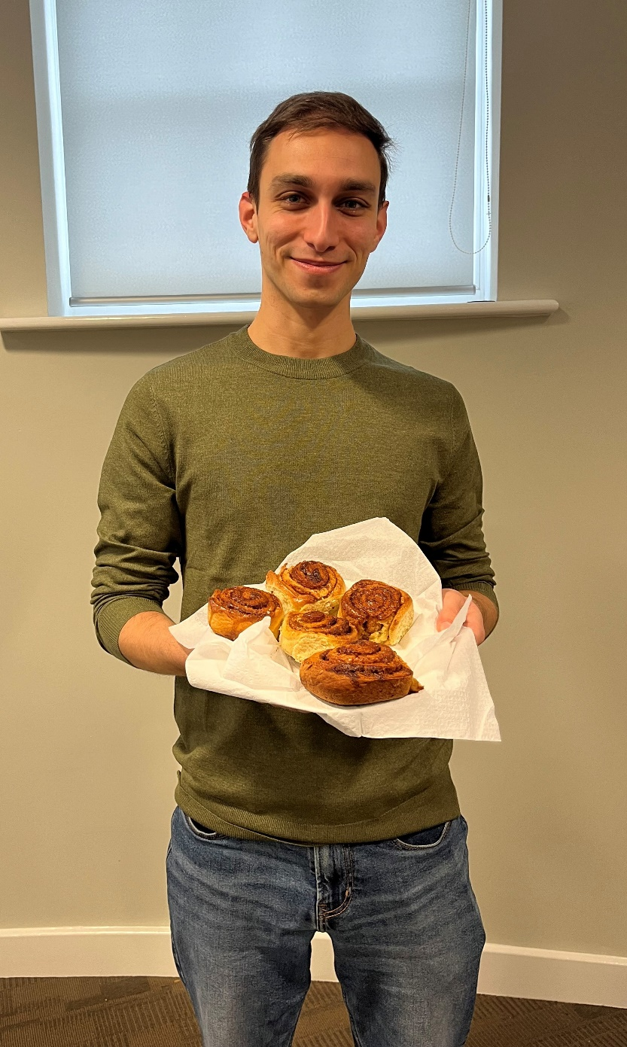

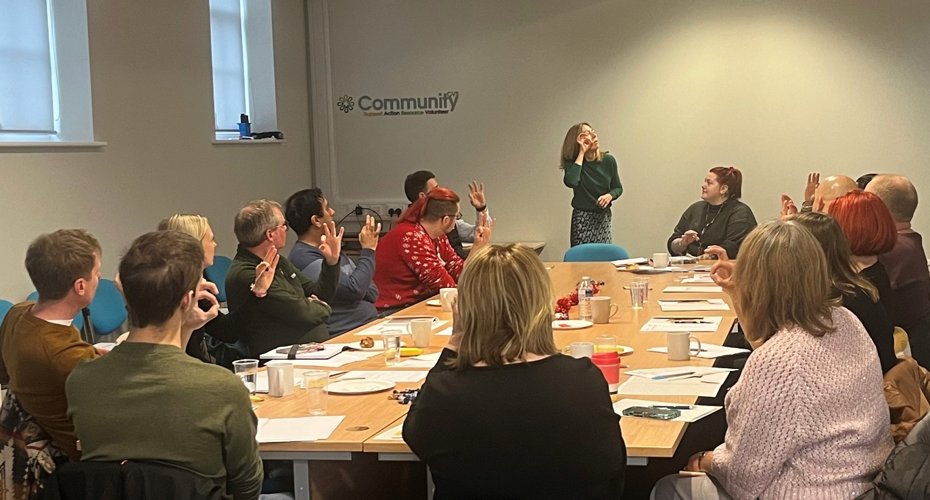

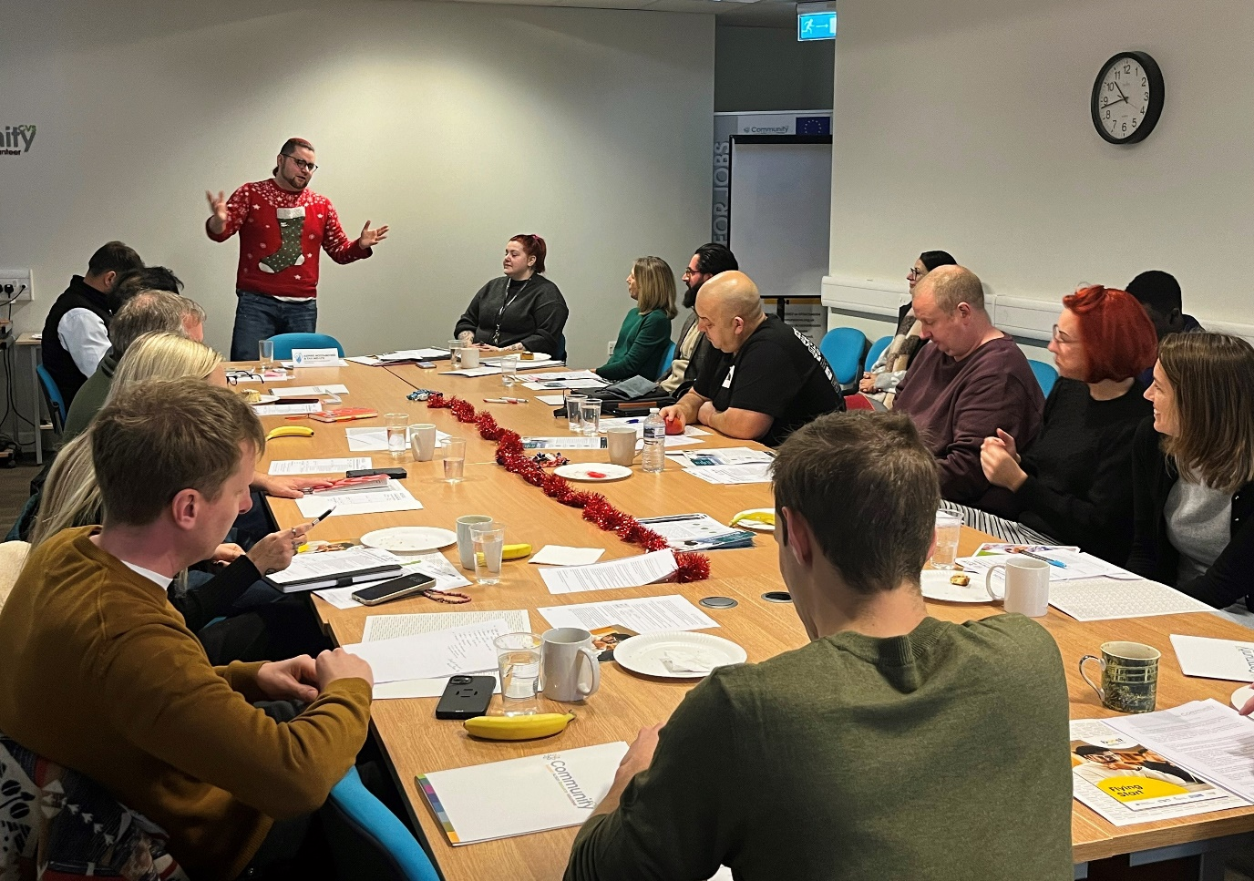**Next Meeting:** 16/01/2025  
- To attend the next Flying Start Business Networking Event, please email [Leah.harrison@communitycvs.org.uk](mailto:Leah.harrison@communitycvs.org.uk)   
  
Or register via the Link: [Boost Flying Start - Business Network | Boost Events](https://boostevents.evolutive.co.uk/event/details/1586081/Boost-Flying-Start---Business-Network)

-If you would like to speak at our next event, please get in touch with the email provide above or call 01254 503043  
  
  
**Location:** Community CVS Boulevard Centre, Conference Room, 45 Railway Road, Blackburn BB1 1EZ  
**Prepared by:** Leah Harrison

**PARKING – please do NOT park on the car park next to the Community Hub – this is a private carpark, and you will be fined.**

**You can now park on Morrisons for Free for 3 hours on any floor. For longer than 3 hours, you can park and pay on the top floor.**