**Meeting Minutes – Flying Start Business Network**  
**Date:** 16/01/2025

**Speaker 1**: Kimberley Helm, Lancashire Careers Hub

**Speaker 2**: Kiran Krishnamoorthy, Soroban IMA Ltd (SIMA)

**Speaker 3**: David Jolliffe, East Lancashire Chamber of Commerce

|  |  |  |
| --- | --- | --- |
| Name | Organisation | Email |
| Leah Harrison | Community CVS | [Leah.harrison@communitycvs.org.uk](mailto:Leah.harrison@communitycvs.org.uk) |
| Kiran Krishnamoorthy | Soroban IMA Ltd (SIMA) | [kiranthiru555@gmail.com](mailto:kiranthiru555@gmail.com) |
| David Jolliffe | East Lancashire Chamber of Commerce | [d.jolliffe@chamberelancs.co.uk](mailto:d.jolliffe@chamberelancs.co.uk) |
| Kimberley Helm | Lancashire Careers Hub | [Kimberley.Helm@inspira.org.uk](mailto:Kimberley.Helm@inspira.org.uk) |
| Philip Quinn | HF Accountancy | [phil_quinn@hotmail.com](mailto:phil_quinn@hotmail.com) |
| Mike Walker | Stop Press | [mike@stoppress.co](mailto:mike@stoppress.co) |
| Eden Maskill-Watts | Eden MW Design Studio | [hello@edenmw.com](mailto:hello@edenmw.com) |
| Allan Harle | Harle Tech | allan@harle.tech |
| Olena Lysenko | Blackburn with Darwen Borough Council | Olena.Lysenko@blackburn.gov.uk |
| Anthony Critchley | Becoming Stellify | ant@becomingstellify.co.uk |
| Salim Chaudhry | Chaudhry, Salim | salim_c_uk@yahoo.co.uk |
| Amy Ainsworth | Travel Assist | [COMMUNITY@TRAVELASSIST.ORG](mailto:COMMUNITY@TRAVELASSIST.ORG) |
| Abiola Laiyenfe | Hermitage Healthcare Limited | [info@hermitagehealthcare.co.uk](mailto:info@hermitagehealthcare.co.uk) |
| Paul Conlin | Conlin Films | [paul@conlinfilms.co.uk](mailto:paul@conlinfilms.co.uk) |
|  |  |  |

**Speaker 1: Kimberley Helm, Lancashire Careers Hub**

**Overview:**  
Kimberley Helm provided an insightful overview of the Lancashire Careers Hub, an initiative designed to bridge the gap between education and employment by working with schools, colleges, and employers. The Careers Hub aims to support young people in gaining essential skills, guidance, and experience to make informed career choices.

**Key Points Discussed:**

* The Careers Hub works with educational institutions and businesses to provide opportunities such as work experience, mentoring, and career workshops.
* Emphasis on the Gatsby Benchmarks, which set a standard for career education and guidance in schools.
* The importance of employer engagement in helping students gain real-world insights and preparedness for future careers.
* Opportunities for businesses to collaborate with schools and colleges to develop industry-specific programmes that align with workforce needs.

**Next Steps:**  
Businesses and professionals interested in getting involved with the Careers Hub can reach out for partnership opportunities to help shape the future workforce of Lancashire.

**Speaker 2: Kiran Krishnamoorthy, Soroban IMA Ltd (SIMA)**

**Overview:**  
Kiran Krishnamoorthy introduced Soroban IMA Ltd (SIMA) and discussed the importance of financial literacy and numeracy skills, particularly in young people and professionals looking to enhance their understanding of financial decision-making.

**Key Insights:**

* SIMA provides interactive learning programmes focusing on improving financial awareness, business acumen, and strategic decision-making.
* The role of numeracy skills in improving employability and economic stability.
* Case studies highlighting the benefits of structured financial education for businesses and individuals.
* How financial literacy can support business owners in making informed financial decisions, reducing risk, and improving sustainability.

**Next Steps:**  
SIMA welcomes collaborations with businesses, educators, and community organisations to expand the reach of financial literacy programmes.

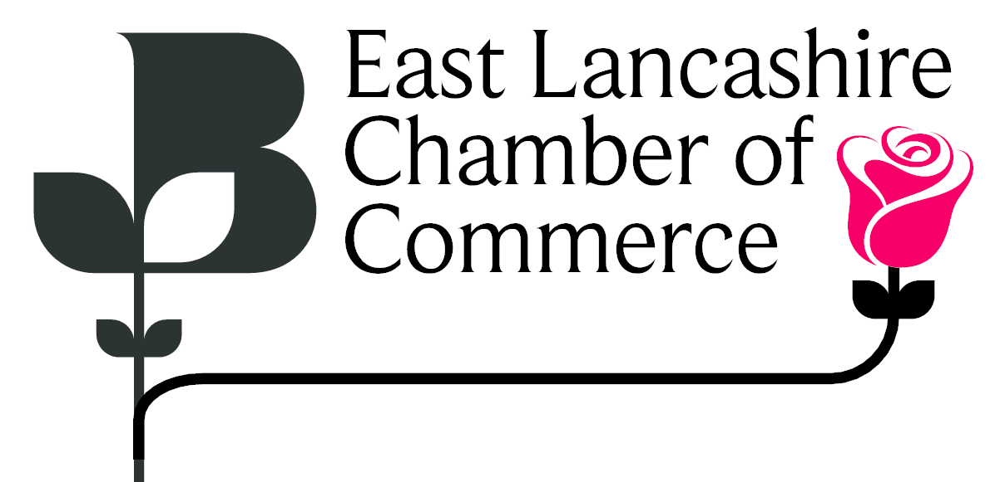**Speaker 3: David Jolliffe, East Lancashire Chamber of Commerce**

**Overview:**  
David Jolliffe provided an update on the Chamber of Commerce’s ongoing efforts to support businesses in the region, with a particular focus on economic growth, sustainability, and networking opportunities.

**Key Takeaways:**

* Updates on business support initiatives, grants, and training programmes available through the Chamber.
* The significance of sustainability and carbon reduction strategies for businesses looking to future-proof operations.
* Networking and collaboration opportunities within the Chamber to foster business growth and innovation.
* Encouragement for local businesses to engage with the Chamber to access resources and funding opportunities.

**Carbon Reduction Strategies:**  
David elaborated on the Chamber Low Carbon programme, which assists businesses in reducing their carbon footprint through tailored carbon footprint reports and reduction plans. He stressed the financial benefits of cutting carbon emissions, such as cost savings on energy use and improved efficiency. Key points included:

* Compliance with upcoming government regulations requiring businesses to monitor and reduce carbon emissions.
* Cost savings through reduced energy consumption and waste reduction.
* Competitive advantage for businesses aiming to secure contracts with government and healthcare institutions like the NHS, which require carbon reduction plans.
* Access to incentives and funding, such as grants from Chorley and South Ribble councils, for businesses with carbon reduction plans.
* Future trends in sustainability, including the role of AI in energy consumption and the importance of sustainable supply chain management.

**Next Steps:**  
Businesses are encouraged to explore Chamber membership to gain access to support services, networking events, and sustainability guidance. Additionally, those interested in carbon reduction plans should act before the UKSPF funding deadline at the end of March to take advantage of free support.

**Additional Contribution: Philip Quinn, HF Accountants**

Philip Quinn, founder of HF Accountants, provided a brief discussion on tax obligations ahead of the 31st January self-assessment deadline.

**Key Points:**

* Individuals who earned over £1,000 between 6th April 2023 and 5th April 2024 must file a self-assessment tax return by 31st January.
* Late filings incur penalties starting at £100, with additional interest charges accumulating over time.
* He offers flexible pricing to support local businesses and individuals in meeting their tax obligations affordably.
* Emerging complexities in taxation for cryptocurrency earnings, with HMRC still refining regulations in this area.

Philip offered to stay after the session for individual queries and encouraged attendees to take action on their tax filings to avoid penalties.

**About the Boost and Flying Start Programme**

**Overview**

The Flying Start service is for early-stage businesses that have traded for less than three years, and aspiring individuals with a great business idea. It is aimed at leaders who have a bright and growing vision for their new business. This service will focus on building business and financial acumen and the core skills to establish a new business and drive sustainable growth.

The advisers on the Flying Start programme have a wealth of experience helping early businesses and entrepreneurs and can provide helpful advice across a wide range of areas including business structure, financial management and bookkeeping, sales and marketing and business planning.  
  
This service is available to businesses within the following partner local authority areas: Blackburn with Darwen Borough Council, Burnley Council, Chorley Council, Fylde Council, Hyndburn Borough Council, Pendle Borough Council, Preston City Council, South Ribble Borough Council, West Lancashire Borough Council and Wyre Council.

**Next Steps**:

* Interested individuals can contact Boost / Selnet for a consultation and guidance on starting or scaling their business.  
  -Link: [Welcome to Boost Flying Start](https://selnet-uk.com/welcome-to-boost-flying-start/)
* Flying Start Business Surgery sessions for those who wish to attend:  
  -The Business Advice Surgery, is a free drop in service available to anyone.  
  -The next session will be held on the 06/02/2025, 9.45am-11.45am at the Community CVS Boulevard centre in Blackburn.   
  -Where attendees will be seen on a first come first serviced basis, for a maximum of half an hour with one of our Business Advisors.  
  - Link: [Boost Business Advice Surgery](https://www.boostbusinesslancashire.co.uk/events/boost-business-advice-surgery10)

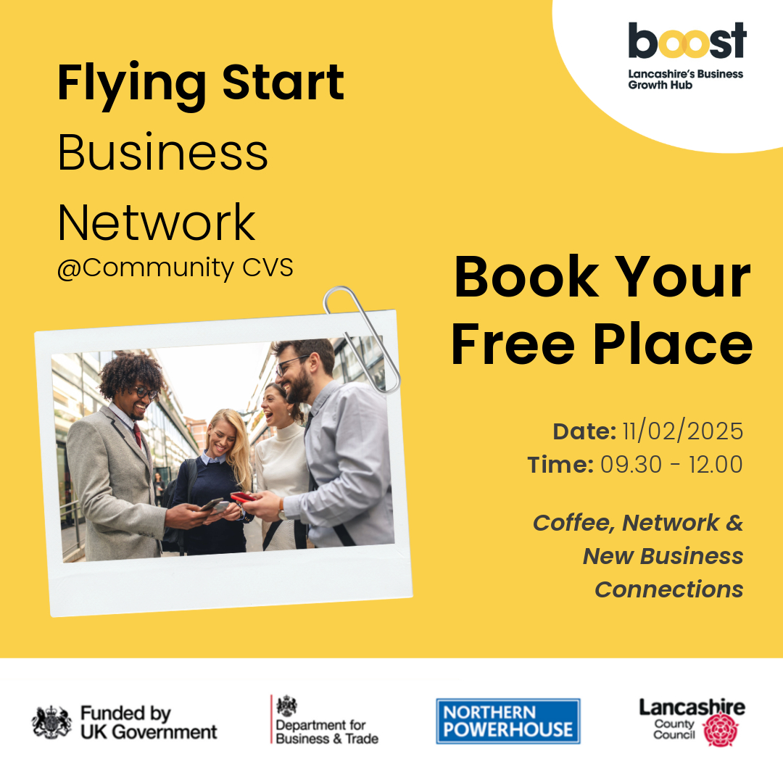

**Additional Information**

**Business Card Raffle Winner:** Allan Harle **Don’t forget your Business Cards for the Next One!**

**Photo:**

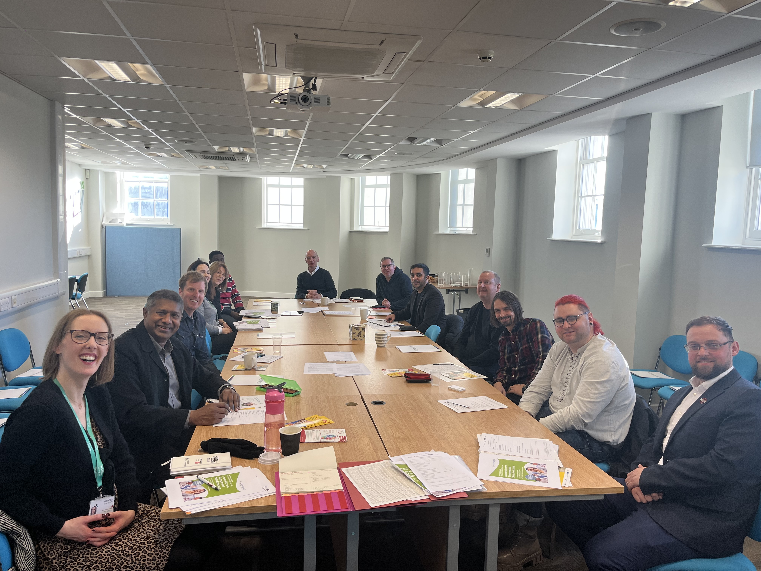

**Next Meeting:** 11/02/2025  
- To attend the next Flying Start Business Networking Event, please email [Leah.harrison@communitycvs.org.uk](mailto:Leah.harrison@communitycvs.org.uk)   
  
Or register via the Link: [Events | Boost Lancashire](https://www.boostbusinesslancashire.co.uk/events?page=2)

**-If you would like to speak at our next event, please get in touch with the email provide above or call 01254 503043**  
  
  
**Location:** Community CVS Boulevard Centre, Conference Room, 45 Railway Road, Blackburn BB1 1EZ  
**Prepared by:** Leah Harrison

**PARKING – please do NOT park on the car park next to the Community Hub – this is a private carpark, and you will be fined.**

**You can now park on Morrisons for Free for 3 hours on any floor. For longer than 3 hours, you can park and pay on the top floor.**

