**Minutes of the CVS Peer Network Meeting**

**Thursday 24th October 2024**

Donna Talbot – CVS [donna.talbot@communitycvs.org.uk](mailto:donna.talbot@communitycvs.org.uk)

Anthony Carr- BwD Refresh - [Anthony.Carr@blackburn.gov.uk](mailto:Anthony.Carr@blackburn.gov.uk)

Kiran Sadiq – BwD Carers Service – [kiran.sadiq@bwdcarers.org.uk](mailto:kiran.sadiq@bwdcarers.org.uk)

Paul Walker – BwD Diabetes Peer Support Group – [BwDdiabetesgroup@outlook.com](mailto:BwDdiabetesgroup@outlook.com)

Zainab Dhukai – Newground Together - [zainab.dhukai@newground.co.uk](mailto:zainab.dhukai@newground.co.uk)

Alan Scholes – Gecko Games Club – [geckoscholes@gmail.com](mailto:geckoscholes@gmail.com)

Glen Sheader – Galloways – [glen.sheader@galloways.org.uk](mailto:glen.sheader@galloways.org.uk)

Andrew Thornhill – BRFC Community Trust – [Andrew.thornhill@brfctrust.co.uk](mailto:Andrew.thornhill@brfctrust.co.uk)

Brenton Mitchell – Fedcap – [Brenton.mitchell@fedcap.org.uk](mailto:Brenton.mitchell@fedcap.org.uk)

Amanda Fletcher – Night safe – [anamda.fletcher@nightsafe.org](mailto:anamda.fletcher@nightsafe.org)

Beverly Ormerod – Neuro Dynamix - [beverleykormerod1511@gmail.com](mailto:beverleykormerod1511@gmail.com)

Denise Hayhurst – Community CVS/LACVS – [denise.hayhurst@communitycvs.org.uk](mailto:denise.hayhurst@communitycvs.org.uk)

Younus Khan – Pukar Disability Centre – [Younus.khan@pukar.org.uk](mailto:Younus.khan@pukar.org.uk)

Ruksana Ali – Pukar Disability Centre – [ruksanali.pukar@gmail.com](mailto:ruksanali.pukar@gmail.com)

Alexandra Clayton – Shelter – [Alexandra_Clayton@Shelter.org.uk](mailto:Alexandra_Clayton@Shelter.org.uk)

Amanda Hall

Paul Turner – East Lancs Cricket Club - [pthealthsmart@gmail.com](mailto:pthealthsmart@gmail.com)

Lucy Willder – Alzheimer’s Society –[lucy.willder@alzheimers.org.uk](mailto:lucy.willder@alzheimers.org.uk)

Jessica Farrow – DWP – [DWP.BLACKBURN@DWP.GOV.UK](mailto:DWP.BLACKBURN@DWP.GOV.UK)

Jal Iqbal – BwD BC Library - [Jal.Iqbal@blackburn.gov.uk](mailto:Jal.Iqbal@blackburn.gov.uk)

Uzma Raziq – Super Slow Way – [uzma@superslowway.org.uk](mailto:uzma@superslowway.org.uk)

Mary Muthoni – Corporation Park – Pavillion Café – [muthonmary00@gmail.com](mailto:muthonmary00@gmail.com)

Kevin Smith – Duke of Edinburgh - [Kev.Smith@dofe.org](mailto:Kev.Smith@dofe.org)

Sid – Offload Northwest – [Offload.NWest@hotmail.com](mailto:Offload.NWest@hotmail.com)

Abdul – Offload Northwest – [Offload.NWest@hotmail.com](mailto:Offload.NWest@hotmail.com)

Cathie Hartley – Blackburn College – [Cathie.Hartley@blackburn.ac.uk](mailto:Cathie.Hartley@blackburn.ac.uk)

Jaffa Musa – Northwest Ambulance Service - [Jaffa.Musa@nwas.nhs.uk](mailto:Jaffa.Musa@nwas.nhs.uk)

Rickie West – Arise Centre - [arisecentre@gmail.com](mailto:arisecentre@gmail.com)

**Apologies:** Janine Smith – Blackburn College, Clare Rigby – BwD BC Mubashar Khaliq – NSPCC, Anne James – Calico**,** Bev Marsden – Lancashire Women, Syka Qureshi – Community CVS, Carl Simms – CANW, Faxi ASSI – Lancashire Fire & Rescue, Julie Moran – Herbert Parkinson, Mike Gibson – North West Air Ambulance, Naomi Johnston – Champions BRFC Trust, Natalie Paintin – BRFC Community Trust, Parisa Quaynor – Just Run for Today, Sarah Nataraj – Creative Support, Steve Ball – Pavillion Café, Siama Afzal – SAS Rights, Gill Moloney – DWP, Laura Davies – NHS, Gemma Dodd – Calico,

**Alan – Gecko Games**

* Gecko Games is a club where you can come along and play board games – the group is more than a games club it's about fostering a community
* I want to get kids off electrical devices and back to playing games with the family not just sat looking at a screen
* People of all ages can come along and join in – there are 2 groups
* Well, Being @ Ewood Park Community Hub on a Wednesday 1pm – 5pm and another group on Monday 1pm – 3pm Mind to Muscle @ Euro House, School Lane BB1 2QH
* I have the dedication to grow these 2 clubs and sessions and make the games club sustainable and grow while staying true to my original purpose
* I need funding advise (DT to refer to Community Team for help)

Q: I work with the British Legion, and they run a monthly social club – would you be interested in coming along to work with them? (PT)

A: Yes – I will catch up with you at the end

Q: Have you thought of working with Care Homes? They must provide activities for the residents and are willing to pay well – I will provide you with contact details (DH)

Q: Do you need any more games?

A: No, my wife would kill me!!!

PT – I walk in schools and kids don’t understand the concept of losing or the concept of No – Board games are a brilliant way of teaching children how to lose and win graciously without kicking off.

[(1) Gecko Games Club | Facebook](https://www.facebook.com/groups/522377684531043/?_rdr)

**Bev from Neuro Dynamix**

* I was diagnosed with Neuro Diversity and wasn’t sure what it was – I did some research and decided to set up a CIC so I could support other individuals with Neurodiversity
* I now work within
  + - * + Prisons
        + Job Centre
        + Groups
        + Schools
        + Shelter
        + Care network
* Helping individuals with Neurodiversity, Autism

Q: What type of tasks do you do?

* + - * + Advocacy
        + Form Filling
        + Craft Groups – Diamond art etc
        + Support Parents – ECHP’s
        + Schools – ECHP’s
        + Form Filling – ESA, UC, PIP
        + Support individuals going to hospital/doctors
        + Support individuals in court

Q: Is there just you?

A: No, I have volunteers who help, and I also work alongside the BwD Social Prescribers

Q: How do you challenge Schools with regards to ECHP’s?

A: I’m very persistent, I ensure I have all the relevant evidence before I approach the school

* I find that teachers and agencies are not qualified to work with individuals with Autism, ADHD or Neuro diversity – I have written a course, and I am just waiting for it to be accredited
* Once accredited I would like to go into schools and teach children to understand what it’s like to be Neuro Divers Etc and understand why sometimes children are given special treatment etc

Q: Do you know about Oak Education?

A: Yes

Q: How does your referral process work?

A: Social Prescribers will refer clients to me as do Caer Network – everyone refers individuals to me

Q: Do you have a referral form?

A: Yes

Q: Do you work with Headway?

A: Yes

* My Arts & Craft session is every Monday – Blackburn Library (2nd Floor) 10:30am – 12:30pm

[(1) Facebook](https://www.facebook.com/people/Neuro-Dy-NamiX/61558280501852/?_rdr)

**Ruksana & Younus – Pukar Disability Resource Centre**

Q: What is the population of BwD?

A: around 55,000 people

Q: What percentage do you think of the population have a disability?

A: 1 in 4

Q: What is a disability?

A: You’re disabled under the Equality Act 2010 if you have a physical or mental impairment that has a ‘substantial’ and ‘long-term’ negative effect on your ability to do normal daily activities.

* + - * + Sight loss
        + Mental Health
        + Arthritis
        + Deaf
        + Physical or Mental impairment

Q: How many inmates in Prison are struggling with their mental health?

A: 90%

Q: How many prison inmates cannot read?

A: 60-80%

* The Pukar Disability Resource Centre aims to work with disabled people, their carers and families to maintain their independence, and to make an accessible centre in Preston city centre, where disabled adults and their carers can access information, resources, education and training, using trained staff and volunteers.
* We have been asked to carry out a feasibility test in Blackburn to see if there is a need for a Pukar resource centre here and if it will work, we also want to ID groups and the need of the community
* If you have a disability – you are 3 times more likely to be unemployed and affected by poverty
* Pukar Disability Resource Centre was founded in April 1998 by Poppy Tanna, herself physically disabled – she lost her legs when she was hit by a drunk driver, she became aware of specific needs of black and minority ethnic disabled people and their families while working for other community groups in the Preston area.

Q: How many people don’t use a computer?

A: 40% do not know how to use a computer

* We support carers to access benefits – 1 in 7 carers are unpaid and many carers do not look after themselves at all – we help with form filling, open Universal Credit claims
* We are wanting to mainstream services in Blackburn – a one stop shop, there are lots of amazing things going on in Blackburn but unfortunately many residents are not aware of the services and miss out
* Ruksana has been hosting focus groups, interviewing individuals linking in with organisations and professionals
* Ruksana has identified that the barriers for one group of individuals are completely different for another.
* The BME community face many challenges – language, culture community etc its often thought that the BME community look after their elderly relatives and what might appear as the perfect scenario – Parents living with children, in reality the children are working full time and don’t have the energy to look after their elderly relatives and in some cases the mums end up doing all the cooking because they are at home. Appointments are missed and the elderly relative can feel isolated and wanting to understand what’s going on but cannot be due to language barriers

[About – Pukar Disability Resource Centre](https://pukar.org.uk/about/)

**Jal from BwD Libraries**

* BwD Library service is fortunate to have support from over 100 volunteers who over the last year have given over 8,500 hours of their time
* BwD Council would not be able to run the libraries if it wasn’t for our volunteers
* Our volunteers make a real difference to the service we can provide,
* We have had 3 volunteers who have progressed and now have paid work with the library services
* We also provide work placements and volunteering opportunities for students
* If you have any clients or know anyone looking to volunteer at the library – please direct them to the LVP (Lancashire Volunteering Partnership) and they can see all our opportunities on there

[Become a volunteer in Lancashire • Lancashire Volunteer Partnership](https://lancsvp.org.uk/)

**Zainab from New Ground**

* We are based in The Mall we can help with a number of things – Employment, Training, Energy
* We can support you in your search for employment or training, by being there to answer questions and help build your confidence.
* We will provide confidential support for any challenges you may be facing which are getting in your way of taking control of your life. These may include physical and mental health, debt or money concerns, benefits, childcare or confidence. We’ve seen most things, and you can be assured that we will provide frank, honest and caring support to tackle your barriers.
* 40% of the population in BwD are digitally excluded – we offer a 7-day entry Level 3 course in digital skills – looking at basics such as switching on the computer, how to shop safely online how to complete forms online.
* The course also covers: Word, basic Excel, Internet, Emails
* If you know anyone who would benefit – ask them to pop into the mall and come and have a chat with us
* We are also offering a 2-week bootcamp construction course up at the Shadsworth Youth Hub – after the training the students will all get their CSCS cards

[Help into Work - Newground Together](https://www.newgroundtogether.co.uk/about-us-2/our-structure/service-areas/help-into-work/)

**Sid – Offload Northwest**

* We set up in 2023 – initially a small group but it has grown, we have lost several of our clients to suicide
* Me and Adbul support men and women
* We have:
  + - * Men’s Hub – Mondays 7:00pm – 9:00pm
      * Women’s Hub – Tuesdays 5:30pm – 7:00pm
      * Revive Coffee Morning – 10am – 1:00pm
      * Young Men’s (18 – 24) Thursday evenings
* All the sessions are held at St Pauls Church, I Higher Audley Street
* We have worked with 2,000 men who have come from all over Burnley, Blackburn, Accrington etc
* Due to the high demand, we have now found a venue in Preston – we hold mental Health Monday – we offer breakfast, activities etc
* We also work with other organisations offering food
* Most men at some point in their life have been affected by mental health – we want to beat the stigma and reach more men who are vulnerable and struggling before it's too late
* We have 20 volunteers who all help and do a great job
* Our office is open 24/7 we don't close – we have men contacting us at 2am – just needing someone to talk to
* We have games nights and other activities – one chap who came along had been in a bedsit for 10 years and dint engage with anyone until he came to us, he has been coming for over 22 months, and he is a changed man – he simply wasn't getting the right support – he had fallen through the net

AC: the systems and process are failing individuals – everything is at a set time and if you are struggling with your mental health and you cancel – its 2 strikes and your out- the system is inflexible and fails the people it's supposed to be supporting

Q: Donna, you say the BwD CN has a women's Network Group – why doesn't it have a men's DT: Not a problem – I can set that up for you

**Denise Hayhurst – Community CVS/LACVS**

* Our Free Community Volunteer Training has everything your volunteers need to get the most out of their volunteering
* The programme is delivered on a rolling basis every 2 months. It is a 4 day training delivered over 2 weeks (2 days per week) at the Community CVS Boulevard Centre.
* ***Introduction to Volunteering*** - Monday 3rd March (10:00am – 3:00pm)
  + - * What is volunteering & why is it important
      * Managing Expectations
      * Volunteer responsibilities
      * Team working
      * Communication
      * Confidence & Self-esteem…
* ***Volunteering Safely*** - Tuesday 4th March (10:00am – 3:00pm)
  + - * GDPR
      * Professional Boundaries
      * Equality & Diversity
      * Health & Safety
      * Safeguarding…
* ***Volunteering in Practice*** - Monday 10th March (10:00am – 3:00pm)
  + - * Reflective practice
      * Dealing with Conflict
      * Lone working…
* ***Volunteering in Recovery Services*** -Tuesday 11th March (10:00am – 3:00pm)
  + - * Addiction & Recovery
      * Health & Wellbeing
      * Support Services…
* To Book on Contact Marsy - [marselle.davies@communitycvs.org.uk](mailto:marselle.davies@communitycvs.org.uk)

[Community Volunteer Training – Community CVS](https://www.communitycvs.org.uk/volunteer/community-volunteer-training/)

**Denise Hayhurst – Community CVS**

* Quality Mark Training for Volunteer Managers
* The Valuing Volunteers Quality Mark helps you show that your organisation provides a great experience for volunteers. It’s a sign of quality for funders, volunteers, and the community.
* It’s a free and a simple process!
* We have used focus group feedback from small community groups to develop a quality mark that, unlike national quality marks, is free, accessible and supportive for small community groups with limited time and capacity.
* We will offer tailored support, training, and templates to help you.
* ***How it Works:***
  + - * Attend our workshops for volunteer managers.
      * Self-Assessment: Complete our easy checklist.
      * Support: Get help from other volunteer managers through our workshops, as well as our policy templates if you need them.
      * Submit your policies to us for assessment.
      * Certification: Receive a certificate and digital badge valid for two years.
* Impress Funders: Mentioning you have the quality mark will show funders you have excellence in volunteer management.
* Attract Volunteers: You can give volunteers more confidence that they will have a positive experience.
* Boost Your Profile: Use the Valuing Volunteers logo in your digital and printed publicity.
* Next sessions – 10th Feb 24th Feb and 17th March for more info email Denise

[denise.hayhurst@communitycvs.org.uk](mailto:denise.hayhurst@communitycvs.org.uk)

**Uzma from Super Slow Way**

We have lots of free events, have a look on our website

<https://superslowway.org.uk/events/>



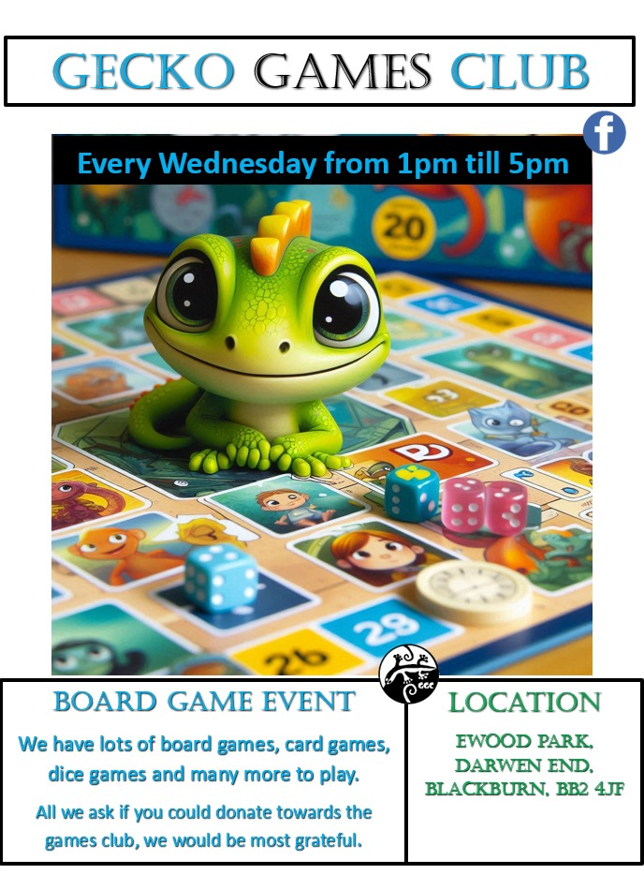

**Next Meeting**

**Thursday 27th February 2025**

**9:30am – 11:30am**

**The Boulevard Centre**

**45 Railway Road, Blackburn BB1 1EZ**

**For more info, please contact Donna Talbot 01254 583957**

[**Donna.talbot@communitycvs.org.uk**](mailto:Donna.talbot@communitycvs.org.uk)

**Parking is free for 3 hours on Morrisons Carpark**