**Meeting Minutes – Flying Start Business Network**  
**Date:** 18/03/2025

**Speaker 1**: **Una Doyle, CreativeFlow.TV**

**Speaker 2**: **Kath Lord-Green, (aka Your Fairy Podmother) of Voice It Podcast Agency**

|  |  |  |
| --- | --- | --- |
| Name | Organisation | Email |
| Leah Harrison | **Community CVS** | [**Leah.harrison@communitycvs.org.uk**](mailto:Leah.harrison@communitycvs.org.uk) |
| Una Doyle | **Creative Flow** | [**una@creativeflow.tv**](mailto:una@creativeflow.tv) |
| Kath Lord-Green | **Your Fairy Podmother** | [**Kath@voiceitpr.com**](mailto:Kath@voiceitpr.com) |
| Philip Quinn | **HF Accountancy** | [**phil_quinn@hotmail.com**](mailto:phil_quinn@hotmail.com) |
| Naomi Dixon | **Naomi Dixon Counsellor** | [**naomidixoncounsellor@gmail.com**](mailto:naomidixoncounsellor@gmail.com) |
| Emma Bolton | **Bolton HR** | [**emma@boltonhr.co.uk**](mailto:emma@boltonhr.co.uk) |
| Faye Strickland |  | [**faye@smithlandelectrical.com**](mailto:faye@smithlandelectrical.com) |
| Tom Doran | **Meritec** | [**tom.doran@mertrec.co.uk**](mailto:tom.doran@mertrec.co.uk) |
| Eden Maskill-Watts | **Eden MW Design Studio** | [**hello@edenmw.com**](mailto:hello@edenmw.com) |
| Matthew Tyler |  | [**matttyler197@gmail.com**](mailto:matttyler197@gmail.com) |
| Brian Spranklen | **Brian Spranklen Photography** | [**brian@spranklenphoto.com**](mailto:brian@spranklenphoto.com) |
| Lisa Yates | **The Mural Lisa** | **hello@themurallisa.co.uk** |
| Sharafat Shah | **Rovers SAS** | [**sshah@attock.co.uk**](mailto:sshah@attock.co.uk) |



**Speaker 1: Una Doyle, CreativeFlow.TV**

**Overview:**  
Una Doyle shared insights into effective business planning, common planning mistakes, and how to set a clear strategic direction for business growth.

**Key Points Discussed:**

* **The Importance of a 90-Day Business Plan**: Breaking goals into short, achievable targets improves focus and productivity.
* **Avoiding Common Mistakes**: Lack of focus, strategic planning, measurement, accountability, and mindset can hinder business growth.
* **Flow in Business**: Business owners should align their operations with their natural strengths and interests to achieve efficiency and sustainability.
* **Practical Steps**: Encouraging attendees to adopt measurement techniques, define clear goals, and seek accountability partnerships.

**Next Steps:**

* Attendees were invited to reflect on their current business strategies and identify areas needing improvement.
* Una offered additional support via workshops and coaching sessions to help businesses with structured planning.

**Speaker 2: Kath Lord-Green, (aka Your Fairy Podmother) of Voice It Podcast Agency**

**Overview:**  
Kath Lord-Green delivered an engaging session on the power of audio content and how businesses can benefit from incorporating podcasts and audio messaging into their marketing strategies.

**Key Insights:**

* **Audio as a Tool for Business Growth**: Podcasts and audio content can enhance brand recognition, lead generation, and customer engagement.
* **Inclusivity & Accessibility**: Adding audio to business communications improves accessibility for those with visual impairments, learning differences, or language barriers.
* **Strategic Podcasting**: Businesses should have a clear purpose for their podcasts, whether for marketing, training, or brand positioning.
* **Practical Steps**: Encouraging businesses to start small with internal audio content before launching full-scale podcasts.

**Next Steps:**

* Businesses interested in using podcasting as a tool for growth were encouraged to explore internal training, brand storytelling, and audience engagement strategies.
* Kath shared resources for those looking to create podcasts without requiring extensive technical knowledge.

### 

### Additional Discussions

As one of the scheduled speakers was unable to attend, additional discussions took place covering key business development opportunities available through Community CVS:

**Aspiring Leaders in Health and Social Care Course – April 23rd Cohort**  
**Overview:**

Leah highlighted the **Aspiring Leaders in Health and Social Care Course**, which has been **well-received by previous participants** and consistently scores **9.5/10 in feedback**.

**Course Details:**

* **Start Date:** April 23rd, 2025
* **Duration:** 10 weeks (one day per week)
* **Target Audience:** Professionals in **health and social care** or the **VCFSE sector** who want to develop leadership and management skills.
* **Topics Covered:** AI in leadership, coaching & mentoring, strategic planning, and operational management.
* **Accreditation:** Optional **Chartered Management Institute (CMI) qualification** available at no extra cost.

**Some participants to attend for free or at a heavily subsidized rate**. Those interested were encouraged to **register early**, as spaces are limited. Naomi Dixon, a current participant, shared her experience, stating that **networking and real-world applications of the course content** were the most valuable aspects.

* **Books in the Business Raffle**: Kath Lord-Green kindly contributed two books to the raffle, including "Your Fairy Podmother Podcast Planner" and "Visible: A Guide to Business Visibility."  
  LINK: [Your Fairy Podmother's Podcast Planner : Lord-Green, Kath: Amazon.co.uk: Books](https://www.amazon.co.uk/Your-Fairy-Podmothers-Podcast-Planner/dp/B0DSLHMX3T)

**About the Boost and Flying Start Programme**

**Overview**

The Flying Start service is for early-stage businesses that have traded for less than three years, and aspiring individuals with a great business idea. It is aimed at leaders who have a bright and growing vision for their new business. This service will focus on building business and financial acumen and the core skills to establish a new business and drive sustainable growth.

The advisers on the Flying Start programme have a wealth of experience helping early businesses and entrepreneurs and can provide helpful advice across a wide range of areas including business structure, financial management and bookkeeping, sales and marketing and business planning.  
  
This service is available to businesses within the following partner local authority areas: Blackburn with Darwen Borough Council, Burnley Council, Chorley Council, Fylde Council, Hyndburn Borough Council, Pendle Borough Council, Preston City Council, South Ribble Borough Council, West Lancashire Borough Council and Wyre Council.

**Next Steps**:

* Interested individuals can contact Boost / Selnet for a consultation and guidance on starting or scaling their business.  
  -Link: [Welcome to Boost Flying Start](https://selnet-uk.com/welcome-to-boost-flying-start/)
* Flying Start Business Surgery sessions for those who wish to attend:  
  -The Business Advice Surgery, is a free drop in service available to anyone.  
  -The next session will be held on the 06/02/2025, 9.45am-11.45am at the Community CVS Boulevard centre in Blackburn.   
  -Where attendees will be seen on a first come first serviced basis, for a maximum of half an hour with one of our Business Advisors.  
  - Link: [Boost Business Advice Surgery](https://www.boostbusinesslancashire.co.uk/events/boost-business-advice-surgery10)

**Additional Information**

**Business Card Raffle Winner: Sharafat Shah**

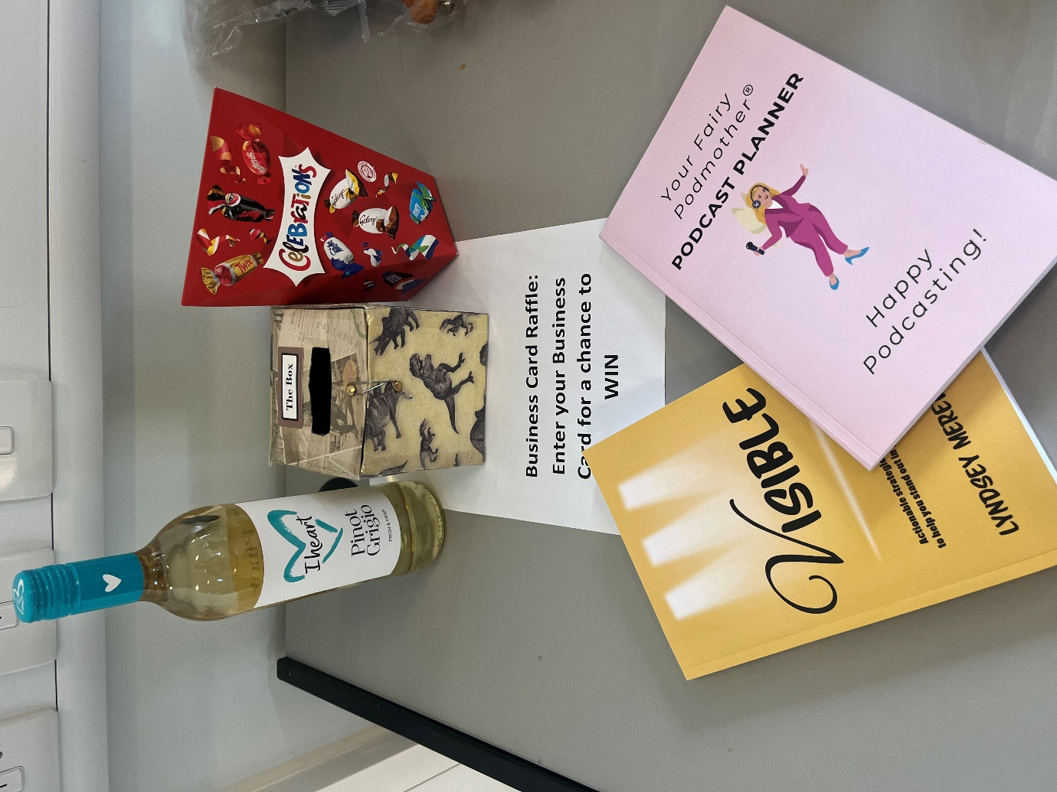

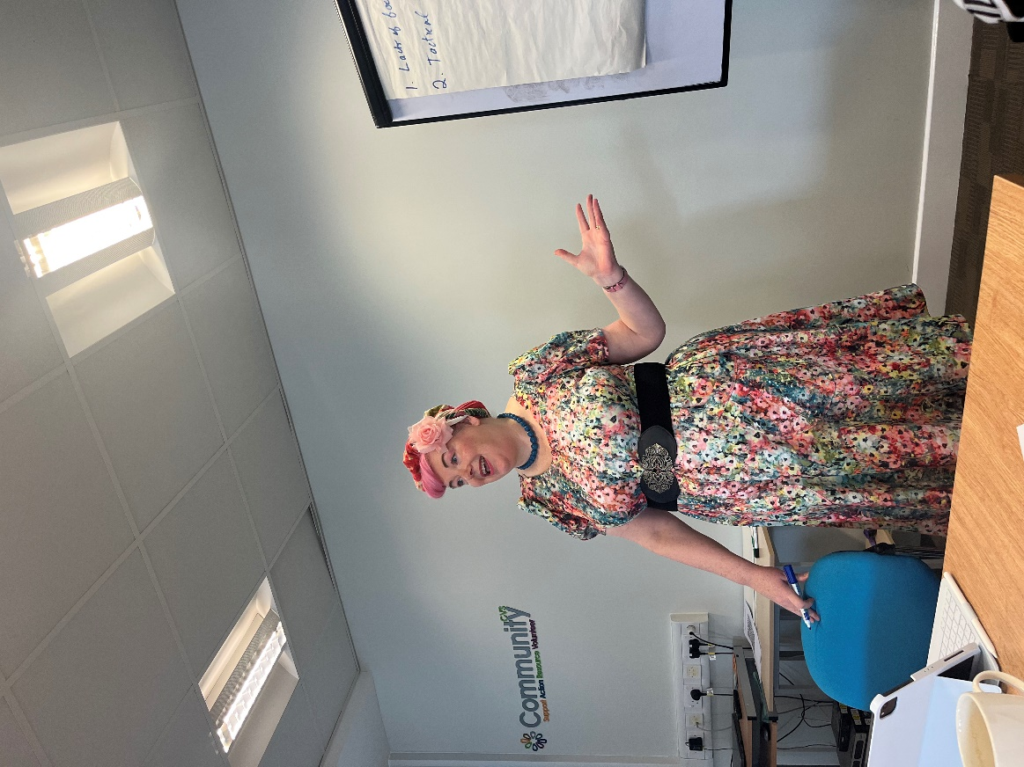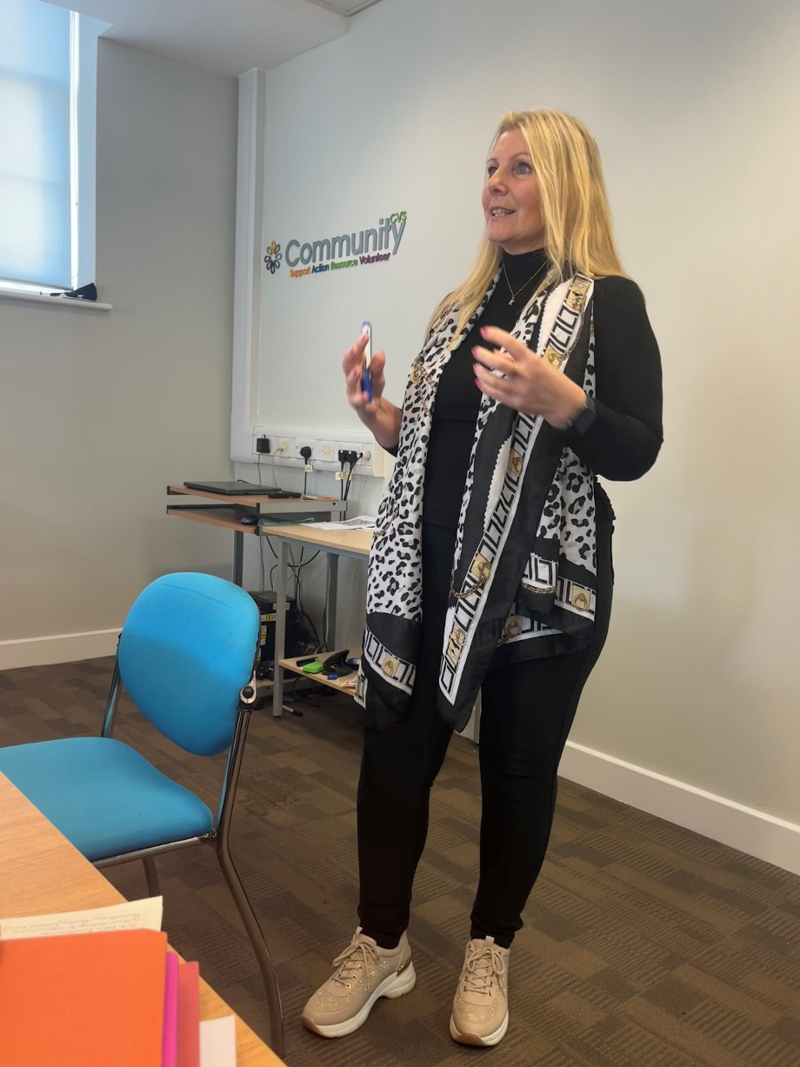**Photo:** 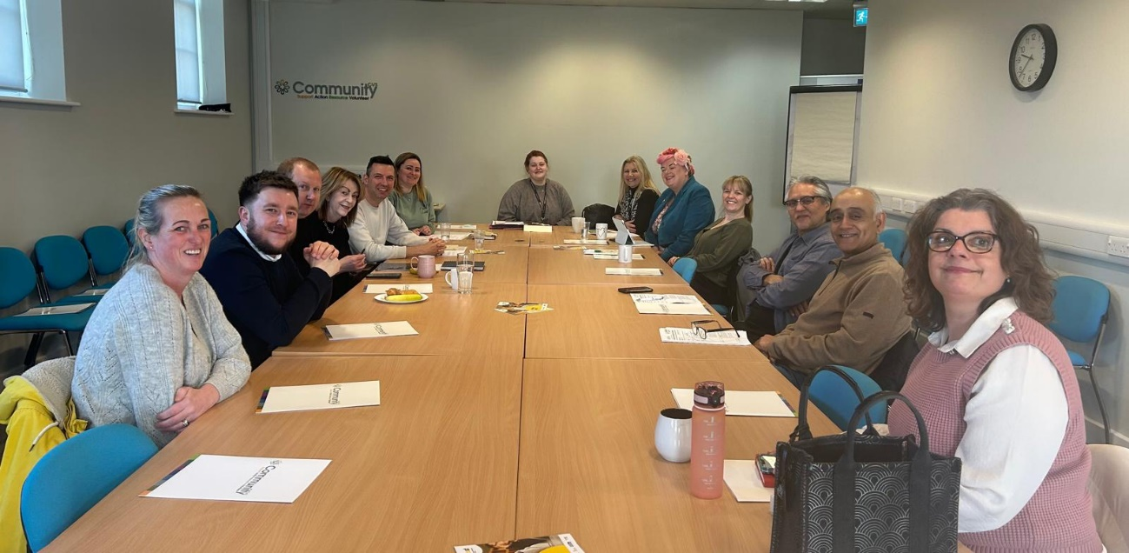

**Next Meeting:**   
- To attend the next Business Networking Event, please email [Leah.harrison@communitycvs.org.uk](mailto:Leah.harrison@communitycvs.org.uk)

**-If you would like to speak at our next event, please get in touch with the email provide above or call 01254 503043**  
  
  
**Location:** Community CVS Boulevard Centre, Conference Room, 45 Railway Road, Blackburn BB1 1EZ  
**Prepared by:** Leah Harrison

**PARKING – please do NOT park on the car park next to the Community Hub – this is a private carpark, and you will be fined.**

**You can now park on Morrisons for Free for 3 hours on any floor. For longer than 3 hours, you can park and pay on the top floor.**