**Minutes of the CVS Peer Network Meeting**

**Thursday 24th October 2024**

Donna Talbot – CVS [donna.talbot@communitycvs.org.uk](mailto:donna.talbot@communitycvs.org.uk)

Kiran Sadiq – BwD Carers Service – [kiran.sadiq@bwdcarers.org.uk](mailto:kiran.sadiq@bwdcarers.org.uk)

Paul Walker – BwD Diabetes Peer Support Group – [BwDdiabetesgroup@outlook.com](mailto:BwDdiabetesgroup@outlook.com)

Brenton Mitchell – Fedcap – [Brenton.mitchell@fedcap.org.uk](mailto:Brenton.mitchell@fedcap.org.uk)

Mary Muthoni – Corporation Park – Pavillion Café – [muthonmary00@gmail.com](mailto:muthonmary00@gmail.com)

Kevin Smith – Duke of Edinburgh - [Kev.Smith@dofe.org](mailto:Kev.Smith@dofe.org)

Sid – Offload Northwest – [Offload.NWest@hotmail.com](mailto:Offload.NWest@hotmail.com)

Abdul – Offload Northwest – [Offload.NWest@hotmail.com](mailto:Offload.NWest@hotmail.com)

Philomena Strickland – Care Network - [philomena.strickland@carenetwork.org.uk](mailto:philomena.strickland@carenetwork.org.uk)

Miffy Clegg – Community CVS - [Miffy.Clegg@communitycvs.org.uk](mailto:Miffy.Clegg@communitycvs.org.uk)

Sarah Riding – Cygnet Fountains – [sarahriding@cygnethealth.co.uk](mailto:sarahriding@cygnethealth.co.uk)

Victoria Crabtree – Suez – [Victoria.crabtree@suez.com](mailto:Victoria.crabtree@suez.com)

Carl Simms – CANW - [csimms@canw.org.uk](mailto:csimms@canw.org.uk)

Hayley Entwistle – Lancashire Women – [Hayley.entwistle@lancashirewomen.org](mailto:Hayley.entwistle@lancashirewomen.org)

Maxine Walsh – Bracebridge/Acer Lodge – [Maxine.walsh@bracebridge.org](mailto:Maxine.walsh@bracebridge.org)

Grace Banham – Lancashire Mind – [gracebanham@lancashiremind.org.uk](mailto:gracebanham@lancashiremind.org.uk)

Filomena Ianni – M2M - [flowianni@gmail.com](mailto:flowianni@gmail.com)

Kev Smith – Duke of Edinburgh – [kevin.smith@dofe.org](mailto:kevin.smith@dofe.org)

Margaret Jepson – Samaritans - [Blackburn.director@samaritans.org](mailto:Blackburn.director@samaritans.org)

John Mcann – LSSA - [saillssa@aol.com](mailto:saillssa@aol.com)

Annie Collier – BwD Food Alliance - [info@bwdfoodalliance.org.uk](mailto:info@bwdfoodalliance.org.uk)

Rachel Coupe – Dance Syndrome – [rachel@dancesyndrome.co.uk](mailto:rachel@dancesyndrome.co.uk)

Karishma Rawoot – Rover SAS – [oneroverssas@gmail.com](mailto:oneroverssas@gmail.com)

Stacey Brown – Brook – [staceybrown@brook.org.uk](mailto:staceybrown@brook.org.uk)

Hannah Vaughn – CANW – [hvaughan@canw.org.uk](mailto:hvaughan@canw.org.uk)

Salma Mohammed – Community Harmony – [salmamesa@yahoo.co.uk](mailto:salmamesa@yahoo.co.uk)

Fozia Aftab – Community Harmony - [communityharmonyproject@gmail.com](mailto:communityharmonyproject@gmail.com)

Gill Maloney – DwP [gill.maloney@dwp.gov.uk](mailto:gill.maloney@dwp.gov.uk)

Muhammad – student BwD Carers

Abdullah – Student BwD Carers

Dawn Juson – Reconnection to Wellness – [reconnectiontw@yahoo.com](mailto:reconnectiontw@yahoo.com)

Scott Johnson – Suez – [scott.johnson@suez.com](mailto:scott.johnson@suez.com)

Karen Marsden – Newground – [karen.marsden@newground.co.uk](mailto:karen.marsden@newground.co.uk)

Danielle Smith – Galloways [Danielle.smith@galloways.org.uk](mailto:Danielle.smith@galloways.org.uk)

Charlotte Kershaw – Mind2Muscle – [charlotte@m2macademy.com](mailto:charlotte@m2macademy.com)

Daniel Sergeant – Suez - [daniel.sergeant@suez.com](mailto:daniel.sergeant@suez.com)

Uzma Khan – Four Seasons Outdoor CIC - [fourseasonsoutdoors.cic@gmail.com](mailto:fourseasonsoutdoors.cic@gmail.com)

**Apologies:**

Janine Smith – Blackburn College, Clare Rigby – BwD BC, Alan Scholes - Gecko Games, Amanda Hayes BwD BC, Andrew Thornhill BRFC Trust, Anthony May – Active Lancashire,

Cathie Hartley – Blackburn College, Dilwara Ali – BwD Healthy Living, Jal Iqbal – BwD BC Library Service, Judith Houghton, Lucy Wilder – Alzheimer’s Organisation, Nazia – One Voice

Jo – Rummage Rescuers, Shelley Whittle NHS Zee Jogi – Zee’s Defence Academy

**Haley – Lancashire Women**

* Lancashire Women in partnership with Deaf Village, Billy Project, BwD BC and Community CVS have organised an event to celebrate International Women’s Day
* Saturday 8th March 10:00am – 1.30pm @ Blackburn Leisure Centre, Feilden Street BB2 1LQ
* The event is free, there will be many stalls promoting Health and Well Being, henna, Zumba a performance by the Deaf Village and a guided history walks with the refresh team
* Everyone is welcome and please spread the word

[Charity Supporting Women in Lancashire](https://lancashirewomen.org/)

**Sid Offload Northwest**

* Started 2 years ago after I lost a friend to suicide, I have been a mental health nurse for many years and wanted to give something back to the community.
* We run a number of Men’s groups: -
  + - Monday Evening 7pm – 9pm
    - Tuesday Coffee Morning 10am – 1pm – both at St Pauls Church, 1 Higher Audley Street BB1 1DH
* We also run a group in Preston, Accrington and we are opening a second men’s group in Blackburn – the groups are open to everyone
* Over the last 2 years we have supported 3000 men – men understand that confidentiality is very important, and we gain their trust
* Historically South Asian men had support from extended family – this isn’t the same any more
* Mental Health is taboo, and men hide the fact that they are struggling
* We offer 24/7 support – if someone needs to talk to someone, we are there: we have What’s App groups to keep in touch with clients, social media – Facebook Page
* We work with partners – Drug & Alcohol, mental health, NHS
* We offer activities – Annie (BwD Food Alliance) came in this week and ran a cooking class with 20 men – a number of the men attending are struggling to eat and sleep due to mental health and low income – so Annie came to show them how to cook and they all thoroughly enjoyed themselves

Q: How and who refers clients to you?

A: Word of Mouth, GP’s other services/groups

Q: Can anyone just turn up?

A: Yes

[(2) Offload Northwest | Facebook](https://www.facebook.com/profile.php?id=100090320945561&sk=about)

**Vic – Suez**

**Dans power point attached**

* Suez currently hold the contract for waste in BwD – it is up for renewal so fingers crossed we will win the contract again

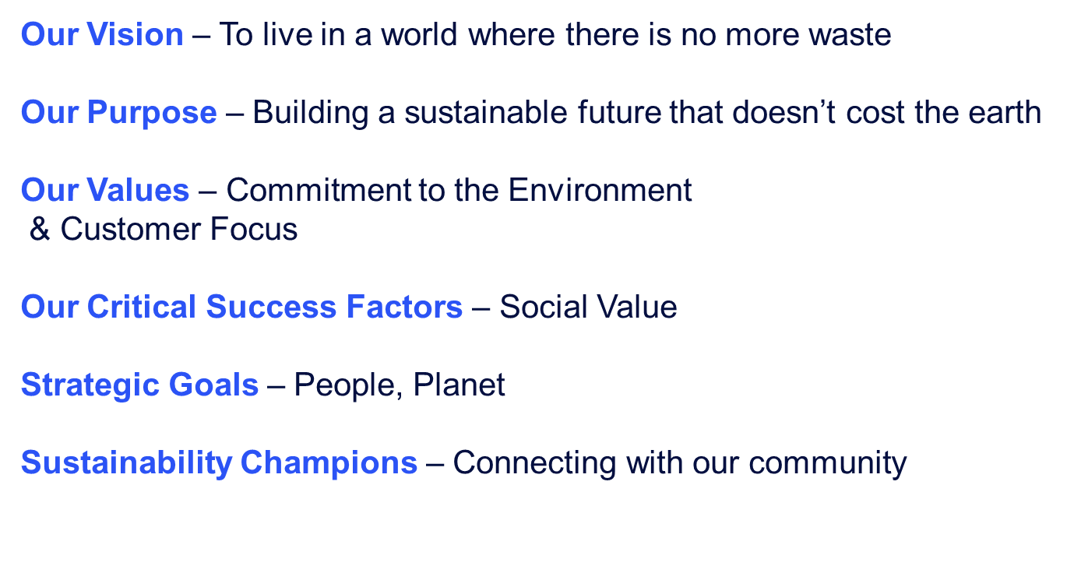

* We have worked with Community CVS for several years – sponsoring the Community Volunteer Awards
* At last years awards event we picked up one of the programmes and decided that we would work with a number of the charities – Night safe, Children’s Storehouse and Active Lancashire
* We have diverted items from the household recycling and donated to our chosen charities – Night safe we have given clothes, sleeping bags etc, Active Lancashire we have donated bikes and The Children’s Storehouse we have donated toys, clothes and baby equipment – all which was destined for landfill
* We want to divert more things – furniture etc so we have come here today to see how we can work with you guys
* We sponsor Blackburn Youth Zone – we also do the annual Christmas Present Wrapping which is the highlight of the year
* We encourage our staff to volunteer – they are paid to volunteer 1 day a year – this could be clean ups – anything
* If you need extra vols – please let us know and we can put it to the staff to see if they want to get involved

Q: A number of the growing groups do not have gardening equipment – is this something you can help with?

A: Yes absolutely

* We have actually started putting posters of the charities on the containers and it has encouraged people to sort their waste and donate items

Q: Rovers SAS are involved with the Green Football Weekend, and we are wanting to recycle old football kits – would you be able to help out with that?

A: Yes, absolutely we have a number of men working onsite I’m sure they will have old kits lying around

[Sustainable waste management in the North of England - SUEZ in UK](https://www.suez.co.uk/en-gb/n-landing-page?utm_source=Google+Business+Profile&utm_campaign=North)

**Fozia – Community Harmony**

* The Community Harmony Café is based in Blackburn we support migrants in the community to become confident community members
* We started 3 years ago, and our main mission was to improve and empower our refugee community in BwD
* We work with the individuals and give them the tools they need to have a sense of belonging – British values etc
* Many of the asylum seekers are very isolated – the children go off to school and become part of the community much quicker than the parents – many of them have language barriers, trauma and need support in simple things like going to the doctors etc – we do have volunteers, but we always need more and volunteers who can speak different languages too
* We meet at the Quakers Meeting house on a Wednesday 10:30am – 1:30pm we have a social aspect were we have a brew, celebrate people’s birthdays etc then the second part we have ESOL classes
* We also hold different social events for the community – guest speakers, services,
* We support the community into volunteering opportunities, training and help signpost to the relevant services
* We help with Physical well-being, confidence building
* We also hold baking classes, art classes etc

[(3) Facebook](https://www.facebook.com/p/Community-Harmony-Project-100088879374084/)

**Karishma – Rovers SAS**

* Rovers SAS is focussed on representing the local South Asian community while connecting with fans from all backgrounds and faiths.
* As mentioned at the CVS meeting today, Rovers SAS are working with the Ramadan Tent Project to host another Open Iftar in Blackburn, and we really hope you can join us for a special evening.
* Following a hugely successful event last year at Ewood Park, the Ramadan Tent Project will once again be hosting their flagship Open Iftar in BLACKBURN! Join us as we break bread together and celebrate Ramadan.
* It gives us great pleasure to invite you to this year's event!
* Location: The Glass Marquee by MyLahore, Stanley House Hotel & Spa, Blackburn
* Date: Friday 28th March Time: From 5.30pm
* Open Iftar is a celebration of community, inclusivity and cultural exchange during Ramadan – and a moment where strangers become friends.
* Open Iftar invites people from all walks of life, and from all faiths and none, to come together for Iftar, the meal that Muslims observe in Ramadan to break their fast at sunset.
* I would appreciate it if you could kindly RSVP by 14th March 2025 by sending an email to us at oneroverssas@gmail.com so we can add you to the guest list.
* The Second Event that we are planning is on Saturday 5th April – we are organising a walk to the football with Uzma from Four Seasons Outdoors CIC
* The walk will commence at Witton Park and the destination is Ewood Park for the match, the purpose of the walk is to get everyone together improving their mental health by being outdoors, the walk is open to everyone – Fathers & Sons, Women’s Groups, Mums and children -everyone we are hoping that this may become a monthly event
* As I mentioned before – Green Weekend in English Football we have a number of things going on – litter picking and recycling kits

Q: Are you looking for just Blackburn Rovers Kits or any football kits?

A: Any team – we just want people to be able to wear a football kit and feel part of the experience

Q: Do you have equipment and High Vis Jackets for the litter pick?

A: No, we haven’t and yes, we do need them

[Rovers SAS group launch a huge success at Ewood Park! | rovers.co.uk](https://www.rovers.co.uk/news/2024/february/07/rovers-sas-group-launch-a-huge-success-at-ewood-park-/)

**Miffy – Community CVS – Bowel Cancer Screening Programme**

* We are looking for volunteers to promote the NHS Bowel Cancer Screening project across Lancashire and Cumbria
* We do have staff but only a small team and they need help with the large inflatable bowel 😊
* We offer full training – especially on how to blow up the large Bowel – the kids love it and it really does make people more comfortable about talking about poo
* Testing has expanded from 65 years plus to 50 plus, so we have a larger target audience to reach.
* It doesn’t matter if you cannot drive, and you do not need any previous experience
* For more details you can go onto the Community CVS Webpage

[Bowel Cancer Screening Programme – Community CVS](https://www.communitycvs.org.uk/index-html/bowel-cancer-screening-programme/)

**Grace - Mind**

* New Project based in BwD supporting individual who have experienced miscarriage and baby loss – we work with the whole family not just mums
* This service offers the following support:
* Free 1-to-1 Therapy Sessions
* Available for individuals directly affected by baby loss or miscarriage within the past two years. These sessions provide personalised support from a qualified therapist. We will be offering either online or face to face therapy within the local area.
* Peer Support Groups
* Designed to create a safe, compassionate space, these groups allow individuals to connect, share understanding, and support one another in their journey through grief. These groups will be open to those impacted by this subject.
* We have 2 focus groups one on 11th March on teams and 26th March face to face

[Together After Loss - Lancashire Mind](https://www.lancashiremind.org.uk/project/together-after-loss/)

**Margaret – Samaritans**

* Samaritans have been working with the university in Strathclyde on a project called Paid Yesterday, Broke Today – looking at low income, inadequate income and the correlation with suicide
* In the report recommendations it stipulates the importance and value of other VCSFE agencies support than the states support
* VCSFE agencies provide support for the individual and this gives them hope – a reason to carry on
* So, I would like to say thank you to you all for your amazing work and support

[Paid_Yesterday_Broke_Today_Report.pdf](https://media.samaritans.org/documents/Paid_Yesterday_Broke_Today_Report.pdf)

[Contact Us | Samaritans](https://www.samaritans.org/how-we-can-help/contact-samaritan/?gad_source=1&gclid=EAIaIQobChMI8N7jjprwiwMVr5NQBh1_EwlcEAAYASAAEgKvmvD_BwE)

**Uzma – Four Seasons**

* + Four Seasons Outdoors offers different opportunities and experiences in the outdoor environment – hiking, local walks, water sports, family days out, retreats
  + We have a new walk – Trailblazer – every fortnight 2 – 8 miles everyone is welcome
  + Walking and being out in nature has a really positive effect on your mental health – just 15 min outside can uplift you for up to 8 hours
  + So, if you, your family, your clients anyone wants to get involved please come along or get in contact

[(3) Facebook](https://www.facebook.com/p/FourSeasons-Outdoors-61553456185696/)

**Filomena – Mind 2 Muscle – Moves and Grooves**

* We offer movement to music for those with Parkinsons, neurological conditions and their family, friends and carers
* We have 2 new classes – offering dance, movement that can ease limitations, lifts spirits and emotional health
* Every Thursday: women only 11:30am – 12:30pm and everyone 1:30pm – 2:30pm
* Euro House, School Lane, Blackburn BB1 2LW – near the hospital

Q: Do you support individuals with progressive MS & strokes?

A: Yes, any neuro physio condition that affects memory, speech etc

Q: Do you need to be referred?

A: No, you can just come along

[Mind2Muscle – Centre Of Excellence](https://www.mind2muscle.co.uk/)

**Next Meeting**

**Thursday 27th March 2025**

**9:30am – 11:30am**

**The Boulevard Centre**

**45 Railway Road, Blackburn BB1 1EZ**

**For more info, please contact Donna Talbot 01254 583957**

[**Donna.talbot@communitycvs.org.uk**](mailto:Donna.talbot@communitycvs.org.uk)

**Parking is free for 3 hours on Morrisons Carpark**